Survey of Patients’ Experience
Hospital Consumer Assessment of Healthcare Providers and Systems Survey
Hospital Name | Summary Star Rating
Brattleboro Memorial Hospital
Central Vermont Medical Center
Copley Hospital
Gifford Medical Center
Grace Cottage Family Health & Hospital* | n/a ¹⁵
Mt. Ascutney Hospital
North Country Hospital
Northeastern Vermont Regional Hospital
Northwestern Medical Center**
Porter Hospital
Rutland Regional Medical Center
Southwestern Vermont Medical Center
Springfield Hospital
University of Vermont Medical Center

*For Grace Cottage Family Health & Hospital, the number of cases/patients is too few to report a star rating.
**For Northwestern Medical Center, the results are based on the hospital or facility’s data submissions. CMS approved the hospital or facility’s Extraordinary Circumstances Exception request suggesting that results may be impacted.
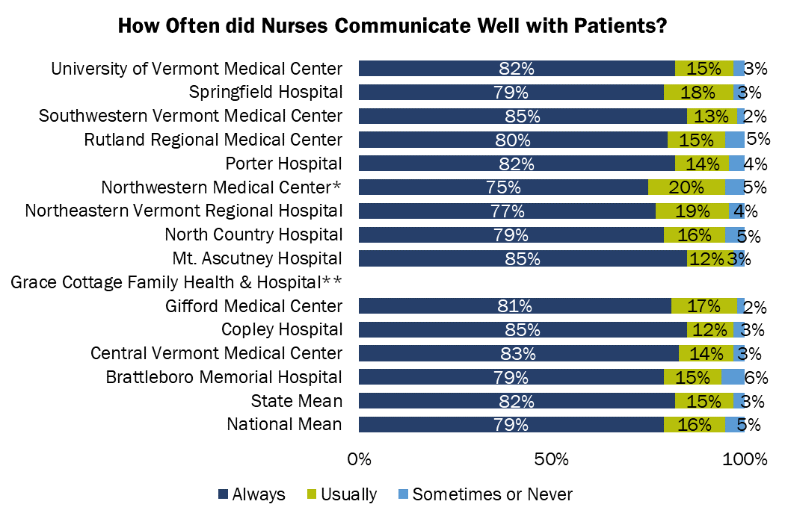

** Grace Cottage Family Health & Hospital’s number of cases/patients are too small to report.
* For Northwestern Medical Center, the results are based on the hospital or facility’s data submissions. CMS approved the hospital or facility’s Extraordinary Circumstances Exception Request suggesting that results may be impacted.
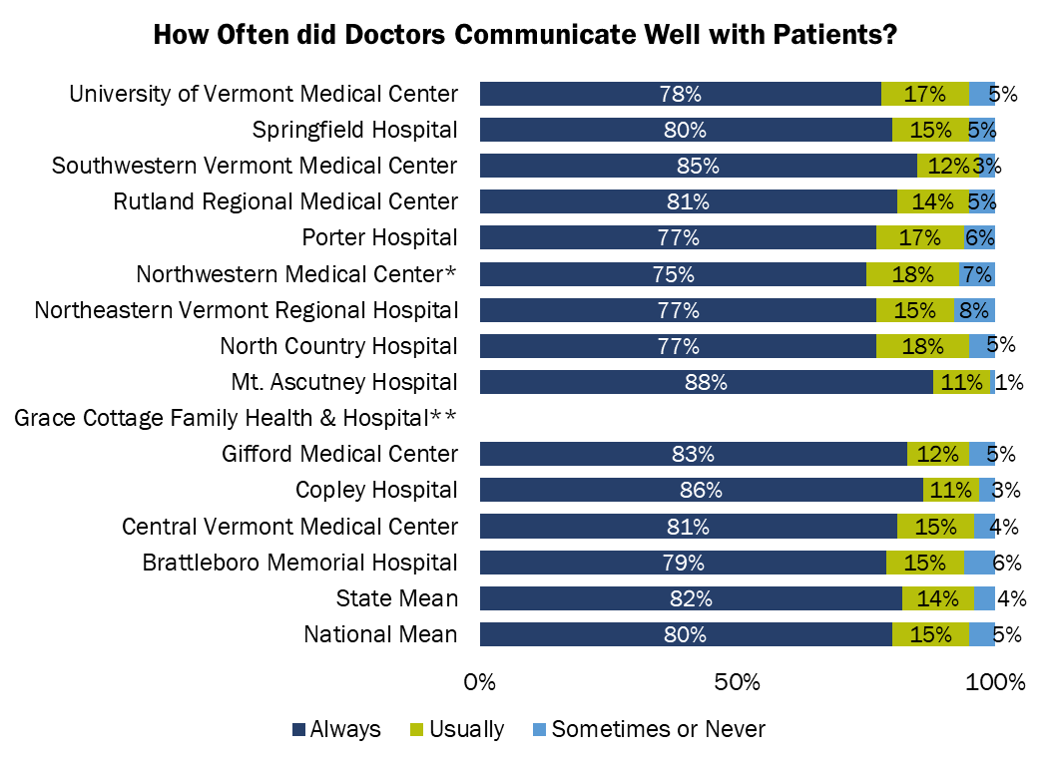
** Grace Cottage Family Health & Hospital’s number of cases/patients are too small to report.
* For Northwestern Medical Center, the results are based on the hospital or facility’s data submissions. CMS approved the hospital or facility’s Extraordinary Circumstances Exception Request suggesting that results may be impacted.

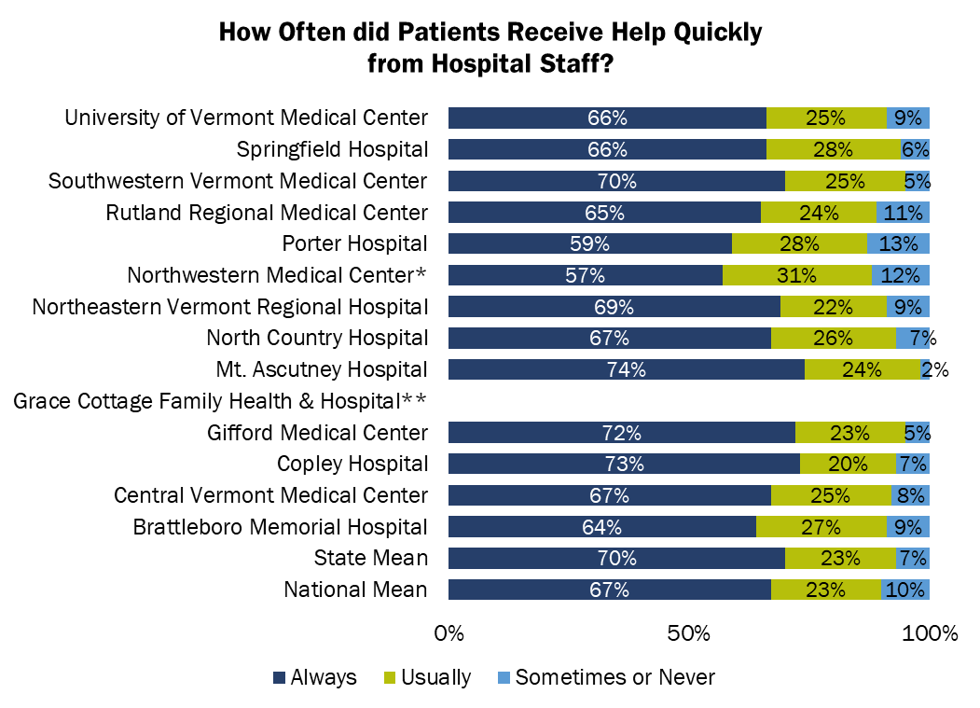
** Grace Cottage Family Health & Hospital’s number of cases/patients are too small to report.
* For Northwestern Medical Center, the results are based on the hospital or facility’s data submissions. CMS approved the hospital or facility’s Extraordinary Circumstances Exception Request suggesting that results may be impacted.
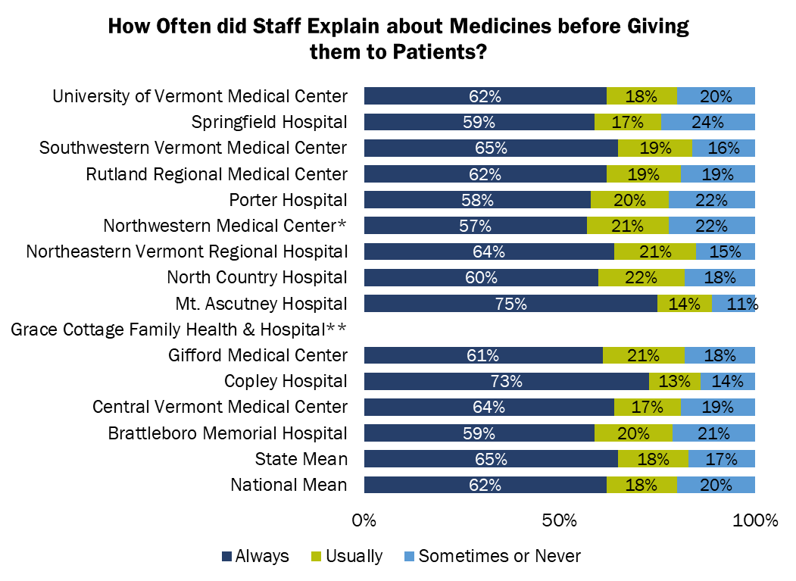
** Grace Cottage Family Health & Hospital’s number of cases/patients are too small to report.
* For Northwestern Medical Center, the results are based on the hospital or facility’s data submissions. CMS approved the hospital or facility’s Extraordinary Circumstances Exception Request suggesting that results may be impacted.
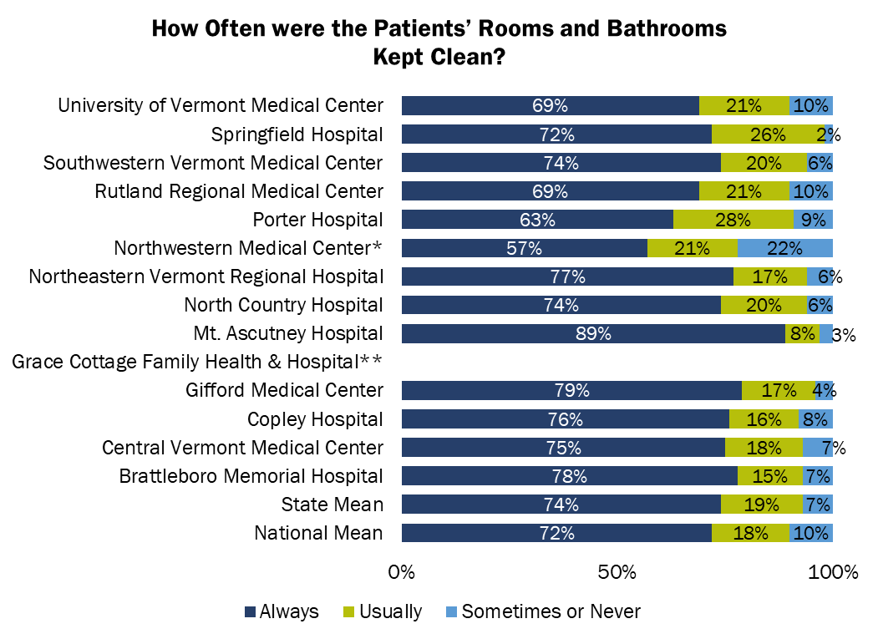
** Grace Cottage Family Health & Hospital’s number of cases/patients are too small to report.
* For Northwestern Medical Center, the results are based on the hospital or facility’s data submissions. CMS approved the hospital or facility’s Extraordinary Circumstances Exception Request suggesting that results may be impacted.
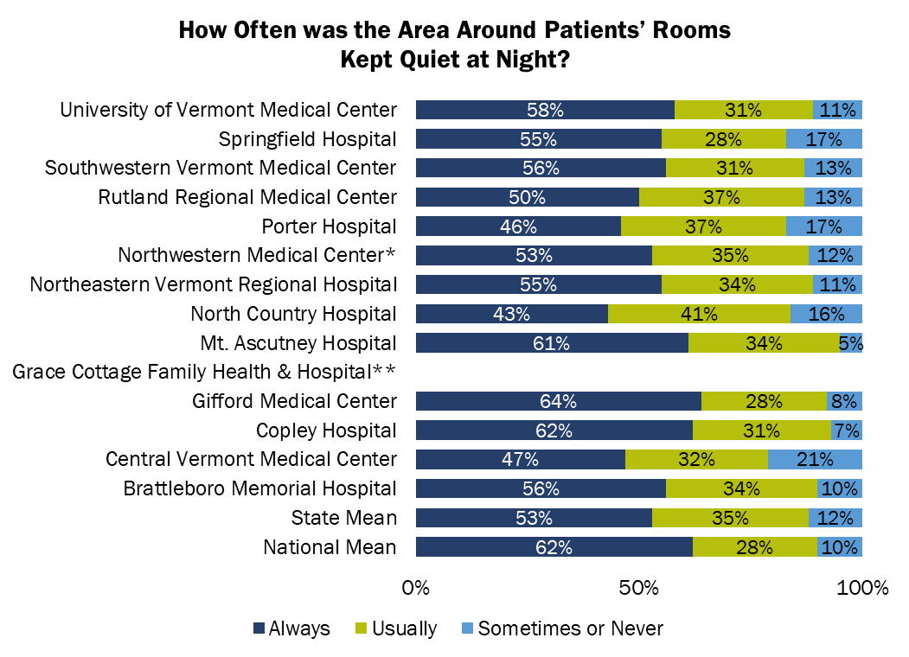

** Grace Cottage Family Health & Hospital’s number of cases/patients are too small to report.
* For Northwestern Medical Center, the results are based on the hospital or facility’s data submissions. CMS approved the hospital or facility’s Extraordinary Circumstances Exception Request suggesting that results may be impacted.
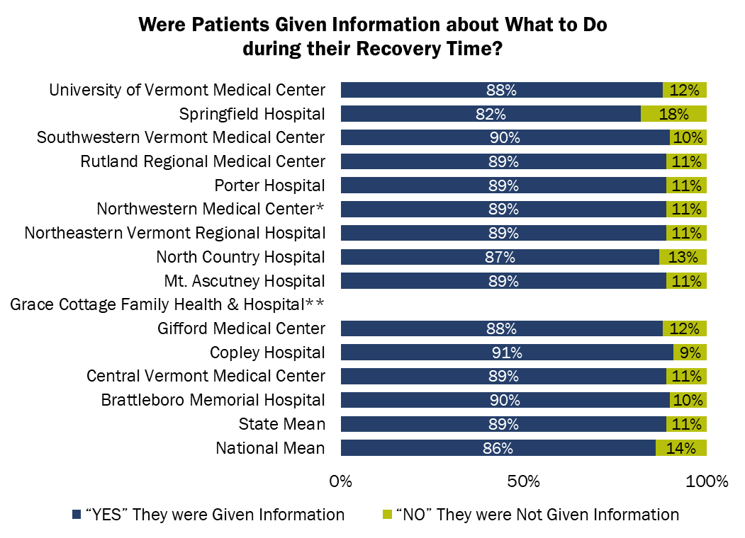
** Grace Cottage Family Health & Hospital’s number of cases/patients are too small to report.
* For Northwestern Medical Center, the results are based on the hospital or facility’s data submissions. CMS approved the hospital or facility’s Extraordinary Circumstances Exception Request suggesting that results may be impacted.
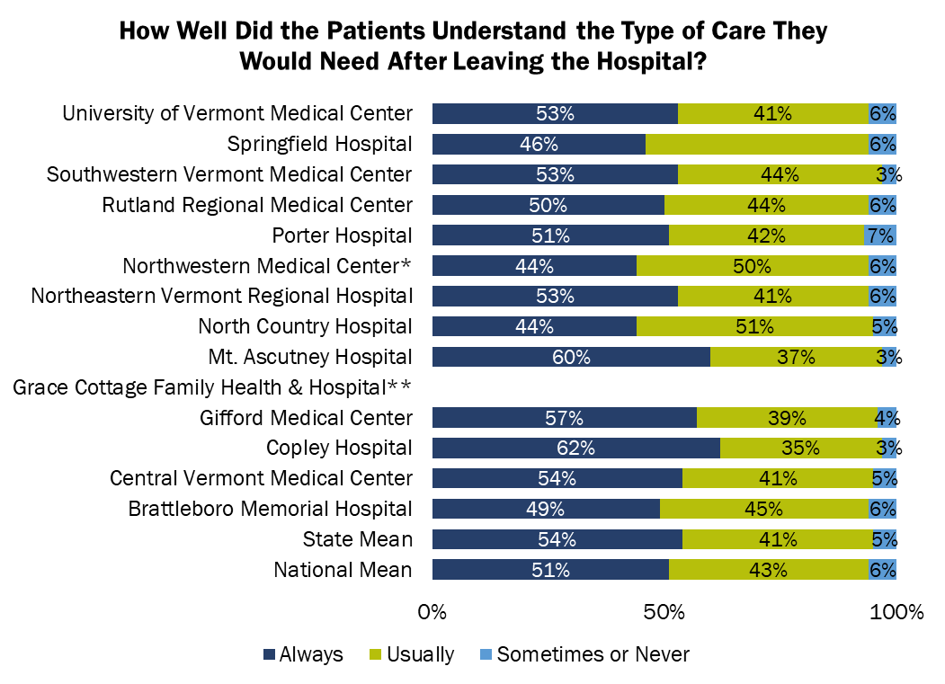

** Grace Cottage Family Health & Hospital’s number of cases/patients are too small to report.
* For Northwestern Medical Center, the results are based on the hospital or facility’s data submissions. CMS approved the hospital or facility’s Extraordinary Circumstances Exception Request suggesting that results may be impacted.

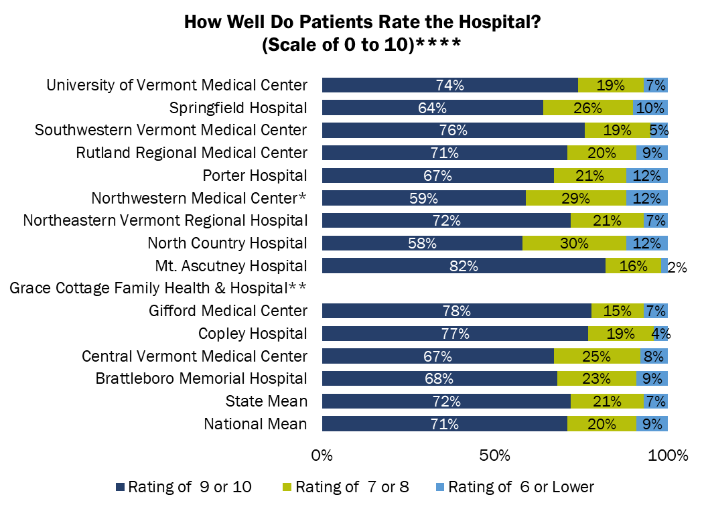
** Grace Cottage Family Health & Hospital’s number of cases/patients are too small to report.
* For Northwestern Medical Center, the results are based on the hospital or facility’s data submissions. CMS approved the hospital or facility’s Extraordinary Circumstances Exception Request suggesting that results may be impacted.
**** 0 means “worst hospital possible”, and 10 means “best hospital possible”.
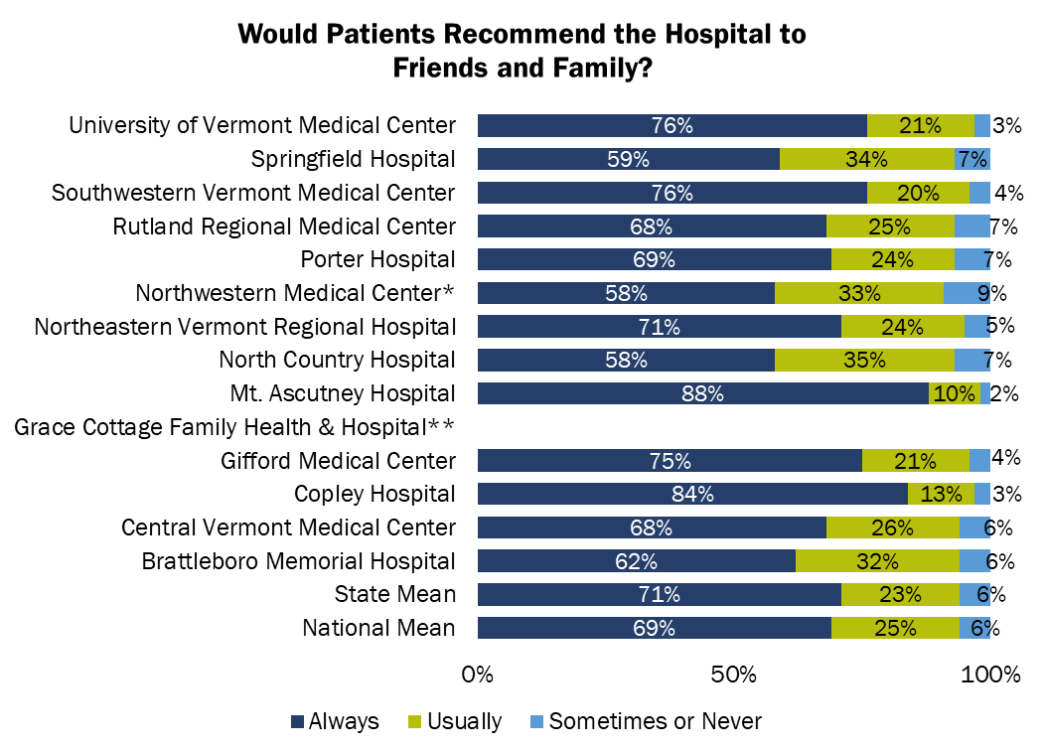
** Grace Cottage Family Health & Hospital’s number of cases/patients are too small to report.
* For Northwestern Medical Center, the results are based on the hospital or facility’s data submissions. CMS approved the hospital or facility’s Extraordinary Circumstances Exception Request suggesting that results may be impacted.

Reporting Period for this report: 7/1/2021 – 6/30/2022

Hospital Name | Number of Survey Completed | Survey Response Rate
Brattleboro Memorial Hospital | 300 | 22
Central Vermont Medical Center | 569 | 23
Copley Hospital | 277 | 32
Gifford Medical Center | 226 | 27
Grace Cottage Family Health & Hospital | n/a ¹ | n/a ¹
Mt. Ascutney Hospital | 178 | 30
North Country Hospital | 187 | 23
Northeastern Vermont Regional Hospital | 231 | 19
Northwestern Medical Center | 360 ²⁸ | 22 ²⁸
Porter Hospital | 228 | 21
Rutland Regional Medical Center | 575 | 22
Southwestern Vermont Medical Center | 407 | 24
Springfield Hospital | 111 | 20
University of Vermont Medical Center | 2658 | 24

1. For Grace Cottage Family Health & Hospital, the number of cases/patients is too few to report.
28. For Northwestern Medical Center, the results are based on the hospital or facility’s data submissions. CMS approved the hospital or facility’s Extraordinary Circumstances Exception request suggesting that results may be impacted.

