Background
Measles cases are on the rise in the U.S. The Centers for Disease Control and Prevention (CDC) is reporting a higher number of U.S. measles cases in 2024 compared to all of 2023. Many countries and travel destinations are experiencing measles outbreaks. Most cases reported in 2024 have been among children aged 12 months and older who had not been vaccinated against measles. Many cases have been linked to international travel.
Measles is almost entirely preventable with vaccines. While most people in the U.S. and Vermont are vaccinated against measles, communities with lower vaccine coverage are at higher risk for outbreaks. U.S. and Vermont rates of measles vaccinations have been declining. In 2024, 93% of registered kindergarteners in Vermont have been vaccinated against measles, but it takes 95% vaccination coverage to achieve community immunity.

How to Use this Toolkit
The Vermont Department of Health needs your help to ensure families are fully vaccinated against measles—especially if they plan to travel outside the U.S.
Please share these sample communication resources on measles and vaccinations with your parents, caregivers and staff. You can customize them as needed for your newsletters, email lists, mailings and other communication channels.
For more information on measles and vaccines, please visit HealthVermont.gov/Measles.
Contents
Sample Newsletter Post #1 2
Sample Newsletter Post #2 3
Sample Letter/Email to Parents 4
Sample Social Media Posts (CDC) 5
Factsheets, Poster and Vaccine Schedule 6

Sample Newsletter Post #1
How to use: Customize and add this post to your newsletter, email list, or other communication channel to help promote measles vaccination. ____________________________________________________________________________________________
U.S. Measles Cases are Rising–Make Sure Your Family is Protected
Measles is a highly contagious respiratory virus that can be dangerous, especially for babies and young children. In the first few months of 2024, there have been nearly twice as many cases of measles in the U.S. compared to all of 2023. Most cases have been in young children who are not vaccinated against measles and who have traveled outside of the U.S.
Here’s how you can help keep your family, school, and community healthy:
- Make sure you and your family are vaccinated against measles—especially if you plan to travel outside the U.S.
  - Children should get two doses of measles, mumps, and rubella (MMR) vaccine—the first dose at 12-15 months and the second dose at 4-6 years.
  - Babies 6-11 months old who are traveling internationally should get an early dose of the MMR vaccine at least two weeks before travel.
- Stay home and call your doctor if your child is sick with symptoms of measles.
Symptoms usually start with a high fever, then a cough, runny nose, and red and watery eyes. A rash usually appears three to five days after the first symptoms. If you do not have a health care provider, call 2-1-1 to be connected to care.
For more information on measles and vaccines, visit healthvermont.gov/measles.
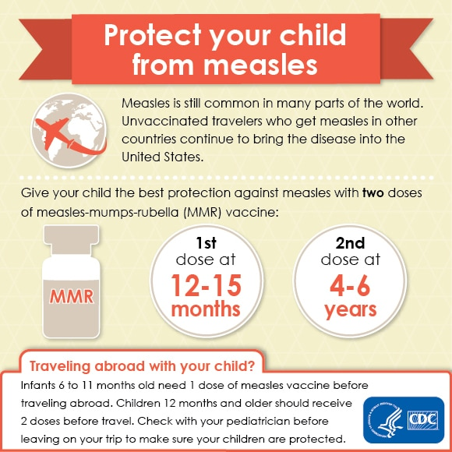
[Download image from CDC]

Sample Newsletter Post #2
How to use: Customize and add this post to your newsletter, email list, or other communication channel to help promote measles vaccination. ____________________________________________________________________________________________
Make Sure Your Family is Protected Against Measles
Measles cases are rising in the U.S. Measles is a highly contagious respiratory virus that can be dangerous, especially for babies and young children. It spreads through the air when people with measles cough or sneeze. It is so contagious that if one person has it, 9 out of 10 people around them may also become infected if they are not immune. Thankfully, measles is almost entirely preventable with vaccines.
Review your and your family’s vaccination records or talk to your doctor to make sure you are well protected against measles—especially before traveling outside of the U.S. Vaccinating your family also helps protect other children from measles who cannot get vaccinated because they are too young or have medical conditions.
For more information on measles and vaccines, visit healthvermont.gov/measles.
[Download image from CDC]

Sample Letter/Email to Parents
How to use: Share this letter with parents and caregivers by copying and pasting it onto school letterhead or in an email message. Please customize as needed.
______________________________________________________________________________
Dear Parent or Guardian,
Measles is a highly contagious respiratory virus that can be dangerous, especially for babies and young children. Measles cases are rising in the U.S., Canada, and other countries. In the U.S., nearly twice as many measles cases have been reported in the first few months of 2024 compared to all of 2023. Most people diagnosed with measles in the U.S. this year have been children ages 12 months and older who had not been vaccinated against measles. Many cases have been linked to international travel.
While most people in the U.S. and Vermont are vaccinated against measles, communities with lower vaccine coverage are at higher risk for outbreaks. Measles is common in some countries so make sure you’re protected against measles before traveling internationally.
Here’s how you can help keep your family, school, and community healthy:
- Make sure you and your family are vaccinated against measles—especially if you plan to travel outside the U.S.
Measles is almost entirely preventable with vaccines. Two doses of the measles, mumps, and rubella (MMR) vaccine are 97% effective against measles.
  - Children should get two doses of MMR vaccine—the first dose at 12-15 months and the second dose at 4-6 years.
  - Babies 6-11 months old who are traveling internationally should get an early dose of MMR vaccine at least two weeks before travel.
Talk to your doctor if you are unsure about your measles protection or to make a vaccine appointment. If you do not have a health care provider, call 2-1-1 to be connected to care. Please share updated immunization information with the school nurse or child care administrator.
- Stay home and call your doctor if your child is sick with symptoms of measles.
Symptoms usually start with a high fever, then a cough, runny nose, and red and watery eyes. A rash usually appears three to five days after the first symptoms. Babies, young children, and people with weak immune systems are at higher risk of getting very sick from measles.
Thank you for taking steps to protect the health of our community. For more information on measles and vaccines, please visit healthvermont.gov/measles.

Sample Social Media Posts (CDC)
How to use: Click on the links to the CDC Facebook and Instagram posts to share them directly to your pages. You can add your custom post copy or use the suggested ones.
Suggested Post Copy | Link to CDC Video
Measles is a very contagious disease caused by a virus. Thankfully, measles can be prevented with measles, mumps, and rubella (MMR) vaccine.  CDC Director Dr. Mandy Cohen explains why it's important for you and your family to stay current on measles vaccination.  Learn more: HealthVermont.gov/measles. | 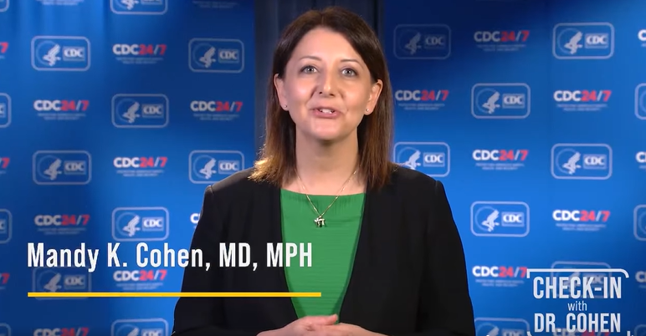  [Go to this CDC Facebook video post and then share to your own Facebook page]
Measles is a very contagious disease caused by a virus. Thankfully, measles can be prevented with measles, mumps, and rubella  (MMR) vaccine.  @cdc.director Dr. Mandy Cohen explains why it's important for you and your family to stay up-to-date on measles vaccination ⬆️  #VaccinesWork #PublicHealth | 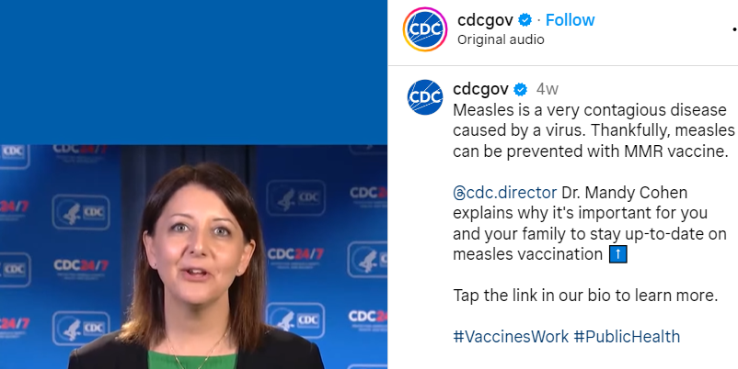  [Go to this CDC Instagram video post and then share to your own Instagram page]
Measles cases are rising in the U.S. This highly contagious respiratory virus can be dangerous, especially for babies and young children.  Make sure you and your family are vaccinated against measles—especially if you plan to travel outside the U.S.  Learn more: HealthVermont.gov/measles. | 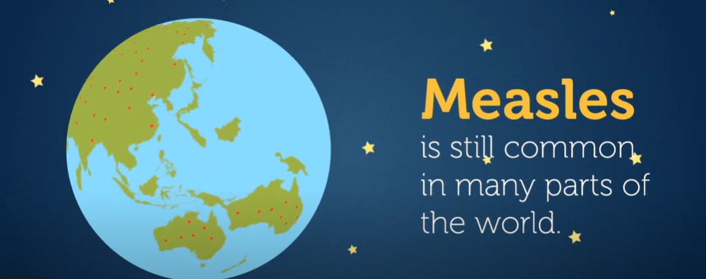  [Add this CDC YouTube video to your post and then add your post copy.

Factsheets, Poster and Vaccine Schedule
How to use: Print to post or share this poster or vaccine schedule handout from the CDC. Find more resources on measles (with some translations) at cdc.gov/measles/resources/parents-caregivers.html. __________________________________________________________________________________________
Measles Factsheet with Translations | 2024 Vaccine Schedule for Children
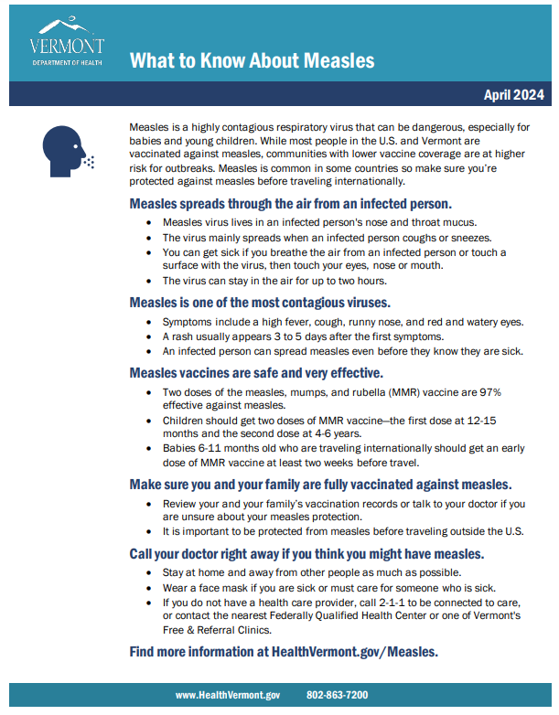 | 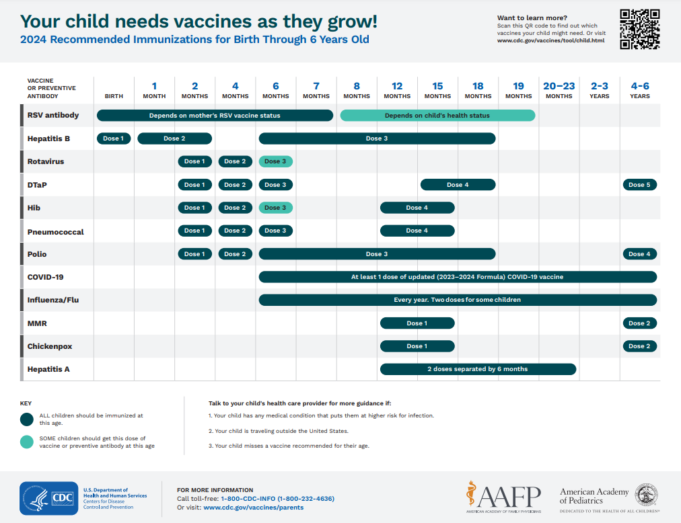
[Click to translated factsheets] | [Download 2024 vaccine schedule]
CDC Factsheet Translated in Ukrainian | Childhood Vaccine Promo Poster
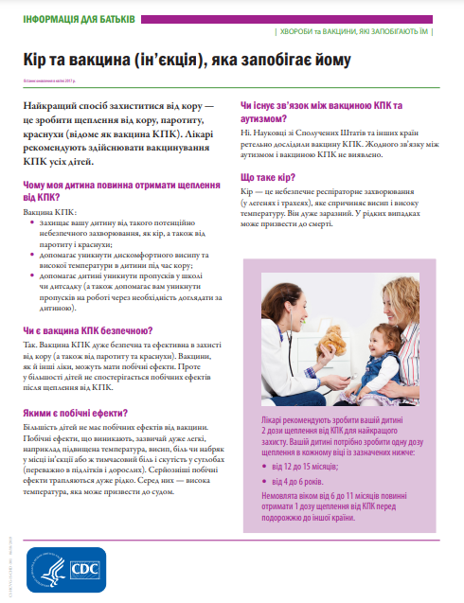 | 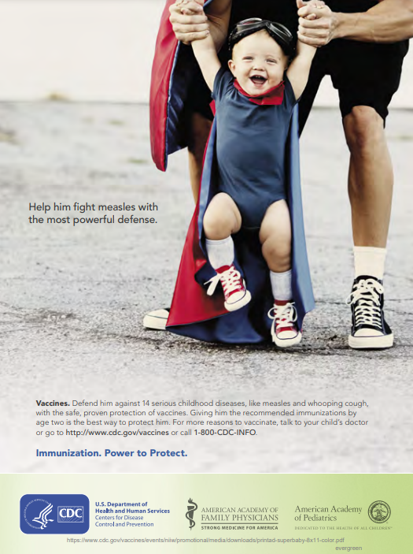
[Download factsheet] | [Download poster]

