Sample Newsletter Post
How to use: Customize and add this post to your own newsletter, email list or other communication channel to help promote norovirus prevention. _____________________________________________________________________________________
Protect Your Family and School Community from Norovirus
This is the time of year when norovirus (sometimes called the “stomach bug”) is more common in Vermont. Norovirus is a very contagious virus that causes vomiting and diarrhea.
You can help keep your family and our school community healthy:
- Wash hands often with soap and water. Remind your child to wash their hands for at least 20 seconds, especially after using the bathroom and before eating or making food. Hand sanitizer does not work well against norovirus!

- Keep your child home for at least 24 hours after symptoms are gone. If your child is recovering from norovirus, staying home for at least 24 hours after all symptoms are gone can prevent norovirus from spreading to other students. Most people recover from norovirus in 1 to 3 days.
For more on norovirus and how to prevent it, visit HealthVermont.gov/norovirus.
[Suggested Image]
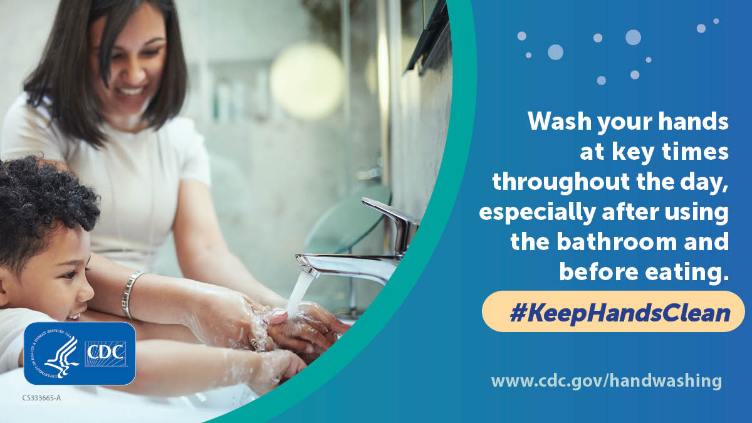

Download image from CDC

Sample Social Media Post
How to use: Customize and add this post to your own newsletter, email list or other communication channel to help promote norovirus prevention. Find more images at https://www.cdc.gov/handwashing/buttons.html
Suggested Post Copy | Facebook/Twitter Image
Early spring is when norovirus (also called the “stomach bug”) peaks in Vermont. A reminder to help keep your family and our school community healthy:  🧼 Wash hands often with soap and water. Hand sanitizer doesn’t work against norovirus!  🏠 Keep your child home for at least 24 hours after symptoms are gone.  Learn more at HealthVermont.gov/norovirus. | 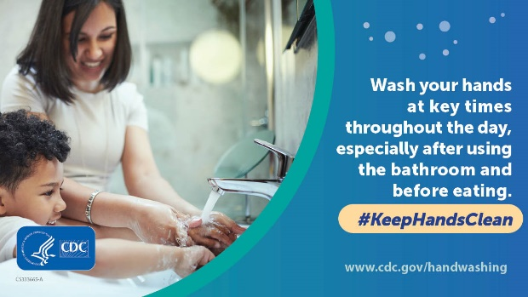  [Download image from CDC]
Sample Fact Sheets
How to use: Download, print or share this handwashing fact sheet from CDC. Find more fact sheets on hand washing at https://www.cdc.gov/handwashing/fact-sheets.html. _____________________________________________________________________________________
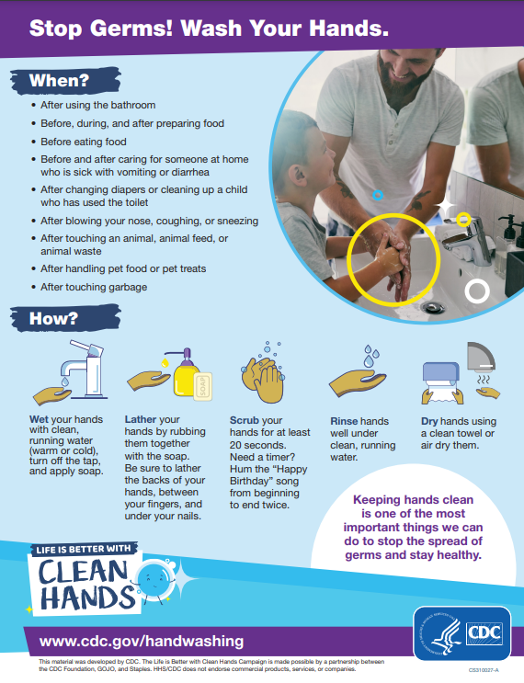  Download fact sheet from CDC | 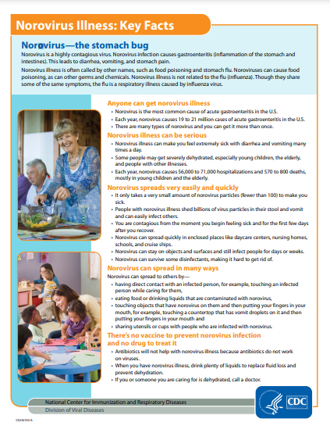  Download fact sheet from CDC

