Respiratory Virus Prevention & Vaccines | Partner Toolkit
2024 Campaign Assets
Customize and share these posts and images to your social media, newsletter, email list or other communication channels to help promote respiratory virus prevention tips, including reminders about COVID-19 and flu vaccines and RSV immunizations.
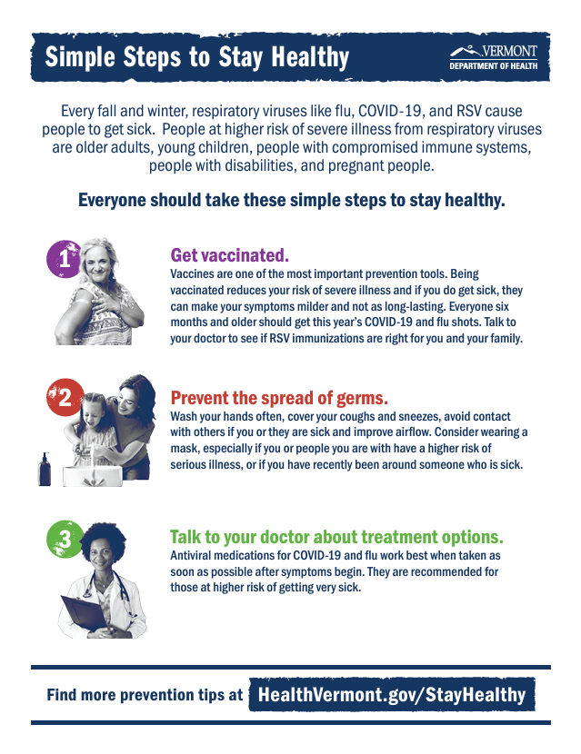
New: Download and print the “Simple Steps to Stay Healthy” 8.5”x11” poster

# | Post Text | Image Text
FACEBOOK & INSTAGRAM
Post 1 - Vaccines | Getting vaccinated against respiratory viruses like flu, COVID, and RSV is one of the most important steps to stay healthy this time of year. Vaccines can keep you from getting seriously ill. And if you do get sick, your symptoms can be milder and not as long-lasting.  Now is the time to get this year’s flu and COVID shots! And talk to your doctor about whether RSV immunizations are right for you or your family. Learn more about it at HealthVermont.gov/StayHealthy | 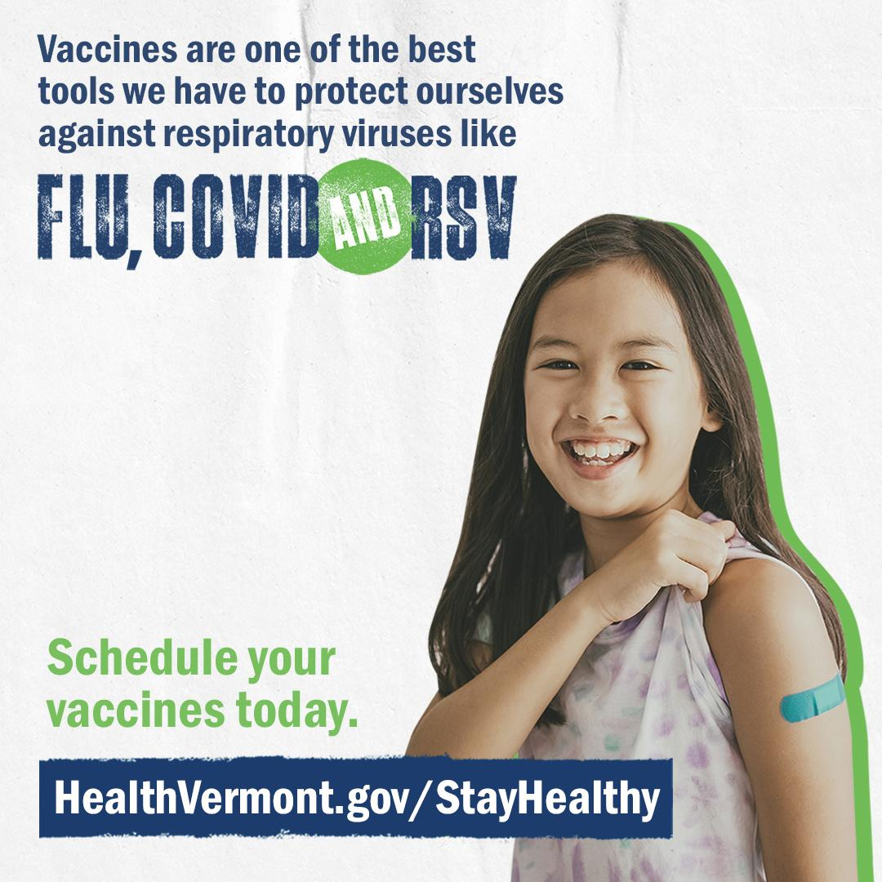  Link to Download
Post 2 - Vaccines | Are you prepared for good health this time of year? Charge up your immune system before the holidays by getting vaccinated against flu and COVID—it's one of the most important ways to stay healthy this season.  Also, talk to your doctor about whether RSV immunizations are right for you or your family. For the latest info on COVID and flu vaccines, visit HealthVermont.gov/StayHealthy | 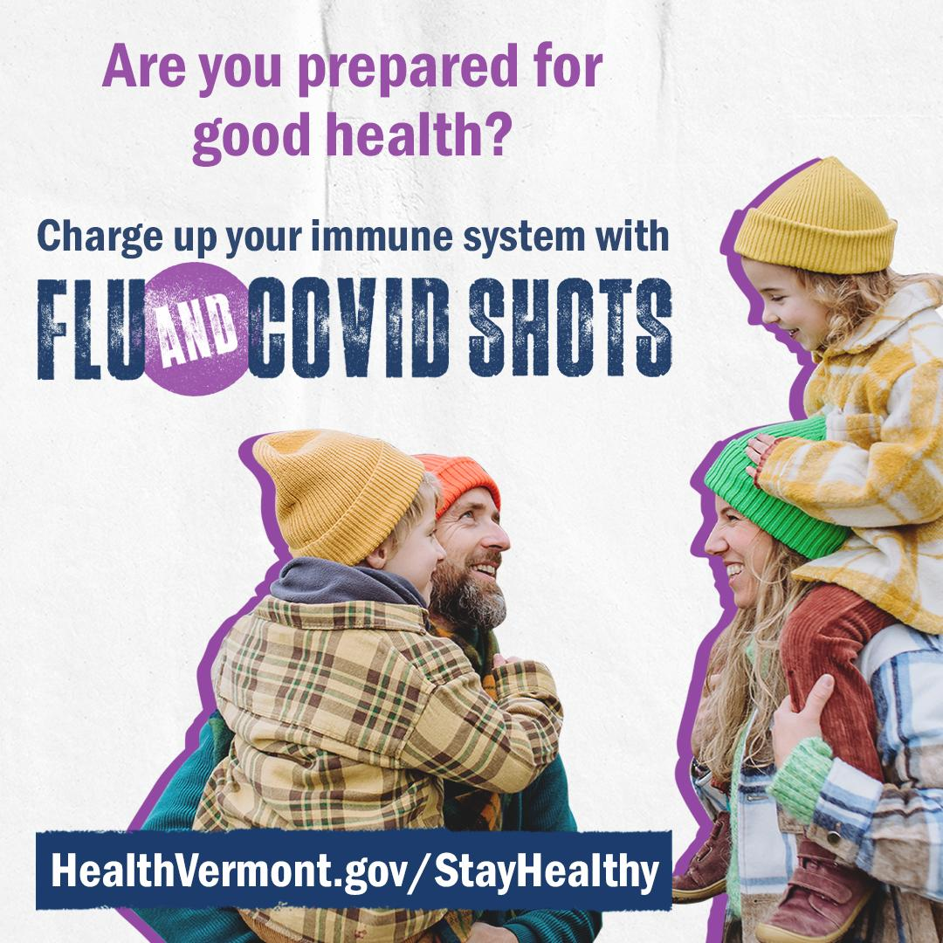  Link to Download
Post 3 - Vaccines | Who’s got time to be sick? Luckily, we have tools to keep us healthy—like vaccines for flu and COVID. Along with getting vaccinated, everyday prevention steps like handwashing, covering coughs and sneezes, and staying home if you are sick could mean more time together this season. For more, visit HealthVermont.gov/StayHealthy | 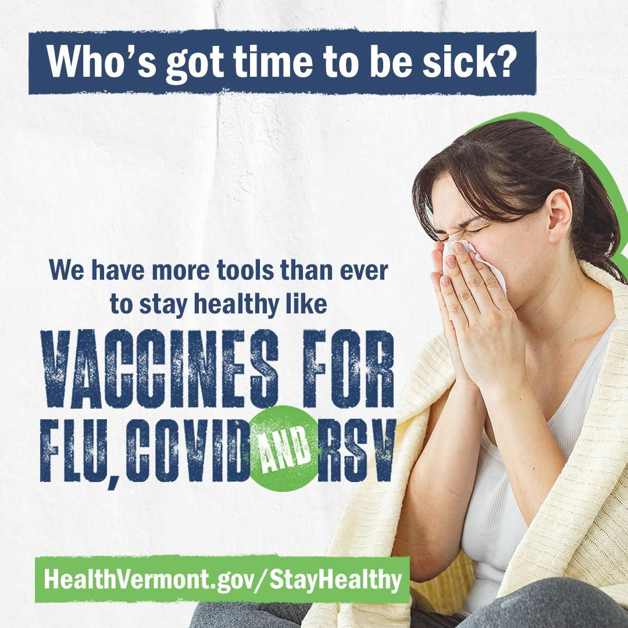  Link to Download
Post 4 - Vaccines | One of the best ways to protect yourself and your loved ones this season is by staying up to date on respiratory virus vaccines for flu and COVID. These vaccines can reduce the severity of illness and help keep you healthy during the colder months. And for most people, vaccines are covered by insurance. Learn more at HealthVermont.gov/StayHealthy | 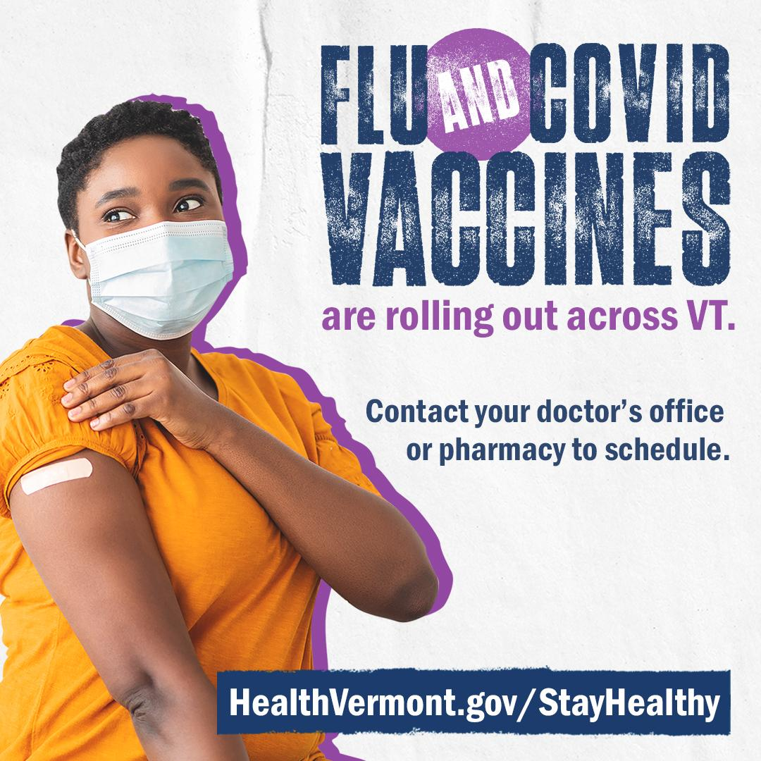  Link to Download
Post 5 - Vaccines | Vaccines are one of the best tools we have to protect ourselves against respiratory viruses like flu, COVID and RSV. Now’s the time to get this year’s shots. Talk to your doctor about whether RSV immunizations are right for you or your family. For the latest info on vaccines, visit HealthVermont.gov/StayHealthy | 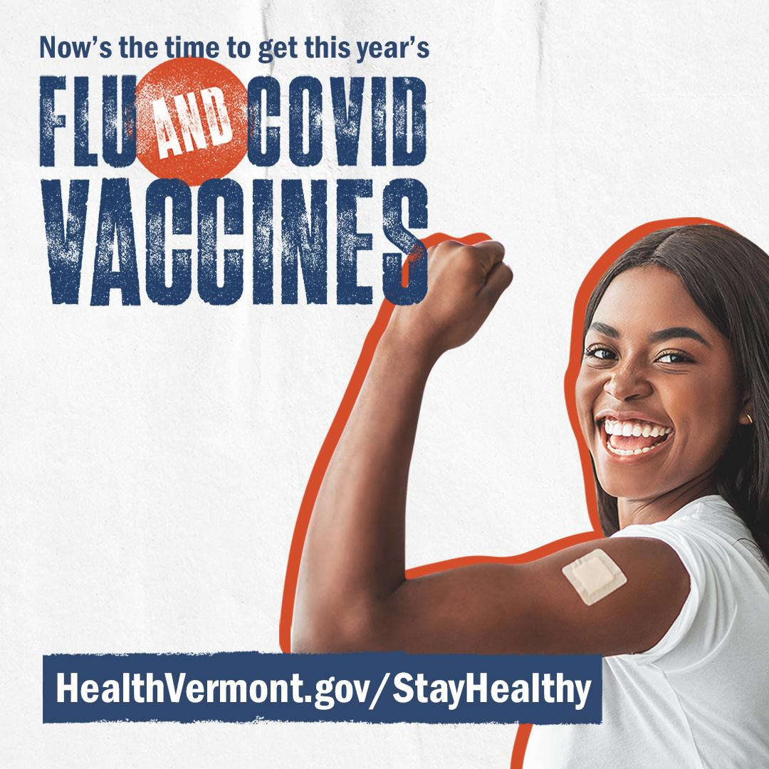  Link to Download
Post 6 - RSV Adults | As we head into respiratory virus season, older adults can get extra protection from RSV from immunizations that help prevent serious illness. Talk to your doctor to find out if RSV immunization is right for you or your loved ones.  For more info, visit HealthVermont.gov/RSV | 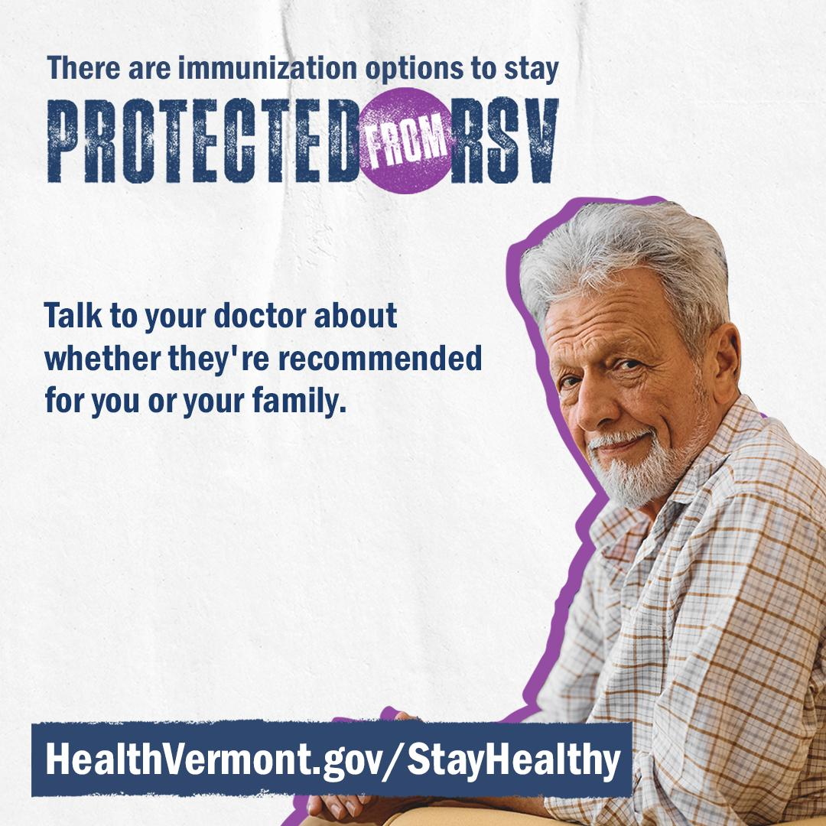  Link to Download
Post 7 - RSV Infants | As we head into respiratory virus season, all infants under 8 months old should receive the RSV antibody shot to protect them from severe RSV infection this year. Talk to your doctor about options to protect your baby from RSV.  For more info, visit HealthVermont.gov/RSV | 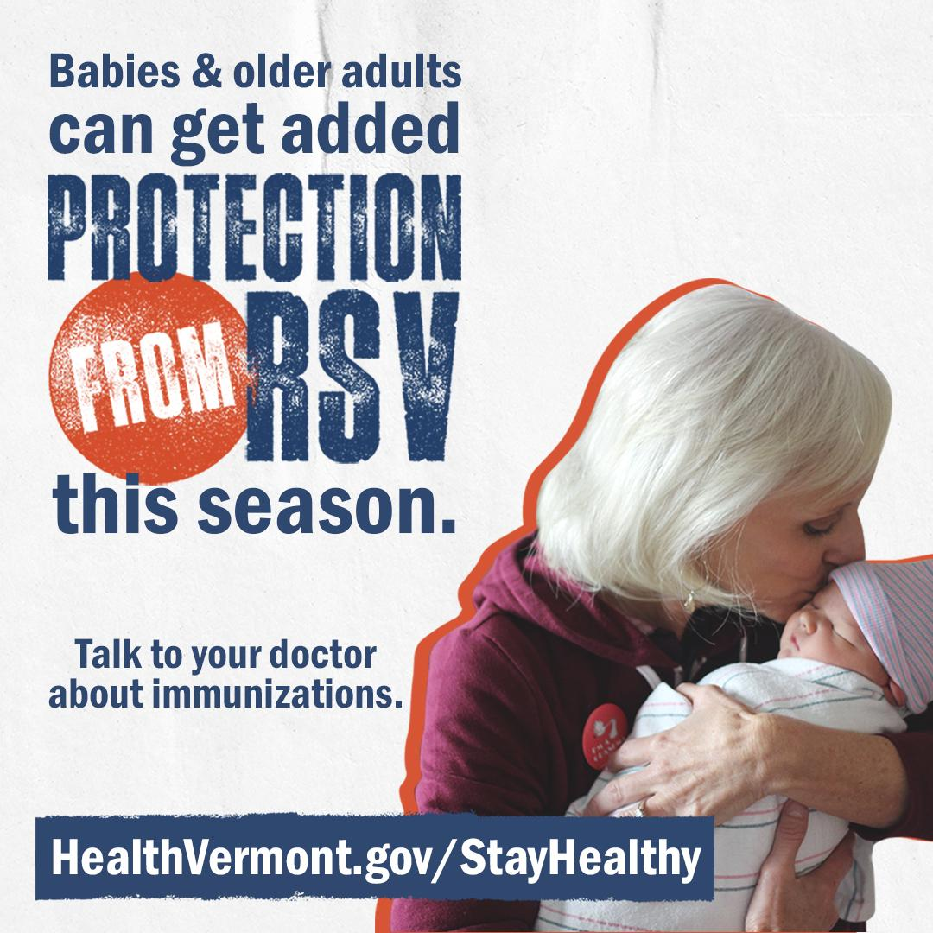  Link to Download
Post 8 - RSV for Pregnant People | Respiratory syncytial virus (RSV) season begins in the fall and peaks in the winter. RSV can be very serious for babies. Getting the RSV vaccine at 32-36 weeks of pregnancy protects infants from severe infection. Talk to your doctor about options to protect your baby from RSV.  For more tips and information on staying healthy this season, visit HealthVermont.gov/StayHealthy | 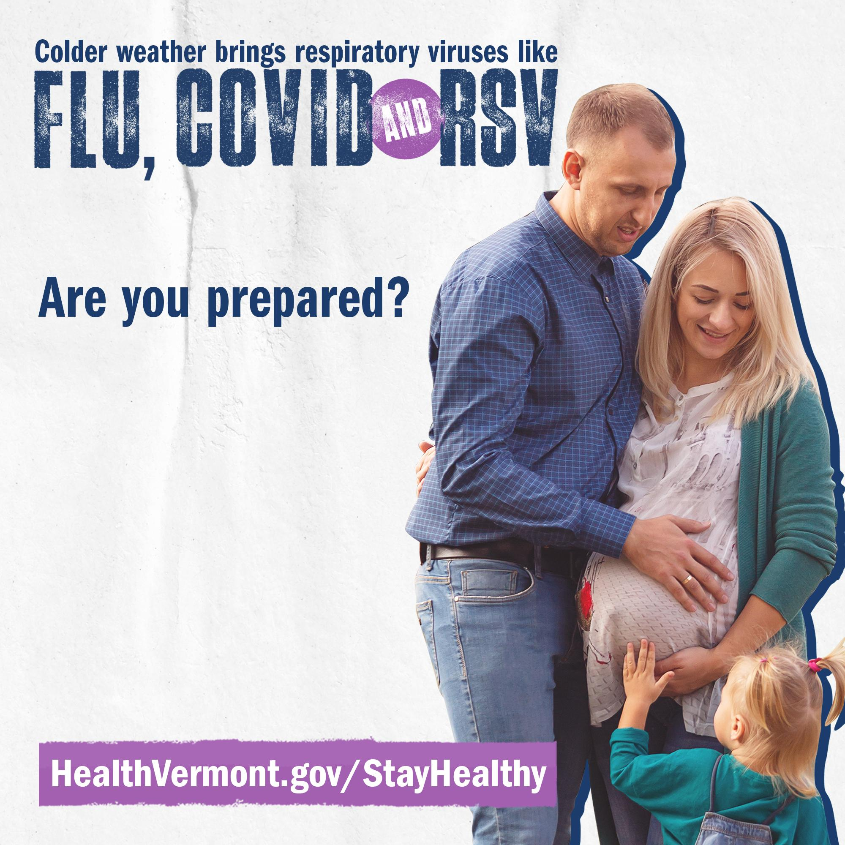  Link to Download
Post 9 - Prevention | With respiratory illnesses on the rise, remember to add these simple steps to your routine to keep yourself and your loved ones healthy:  🧼Wash your hands often with soap and water.  🛏️Avoid contact with others if you or they are sick.  🤧Cover your coughs and sneezes with your elbow or a tissue.  😷Consider wearing a mask, especially if you or people you are with are at higher risk of serious illness.  💉Learn about this year’s vaccines and make a plan to get your shots.  For more tips, visit HealthVermont.gov/StayHealthy | 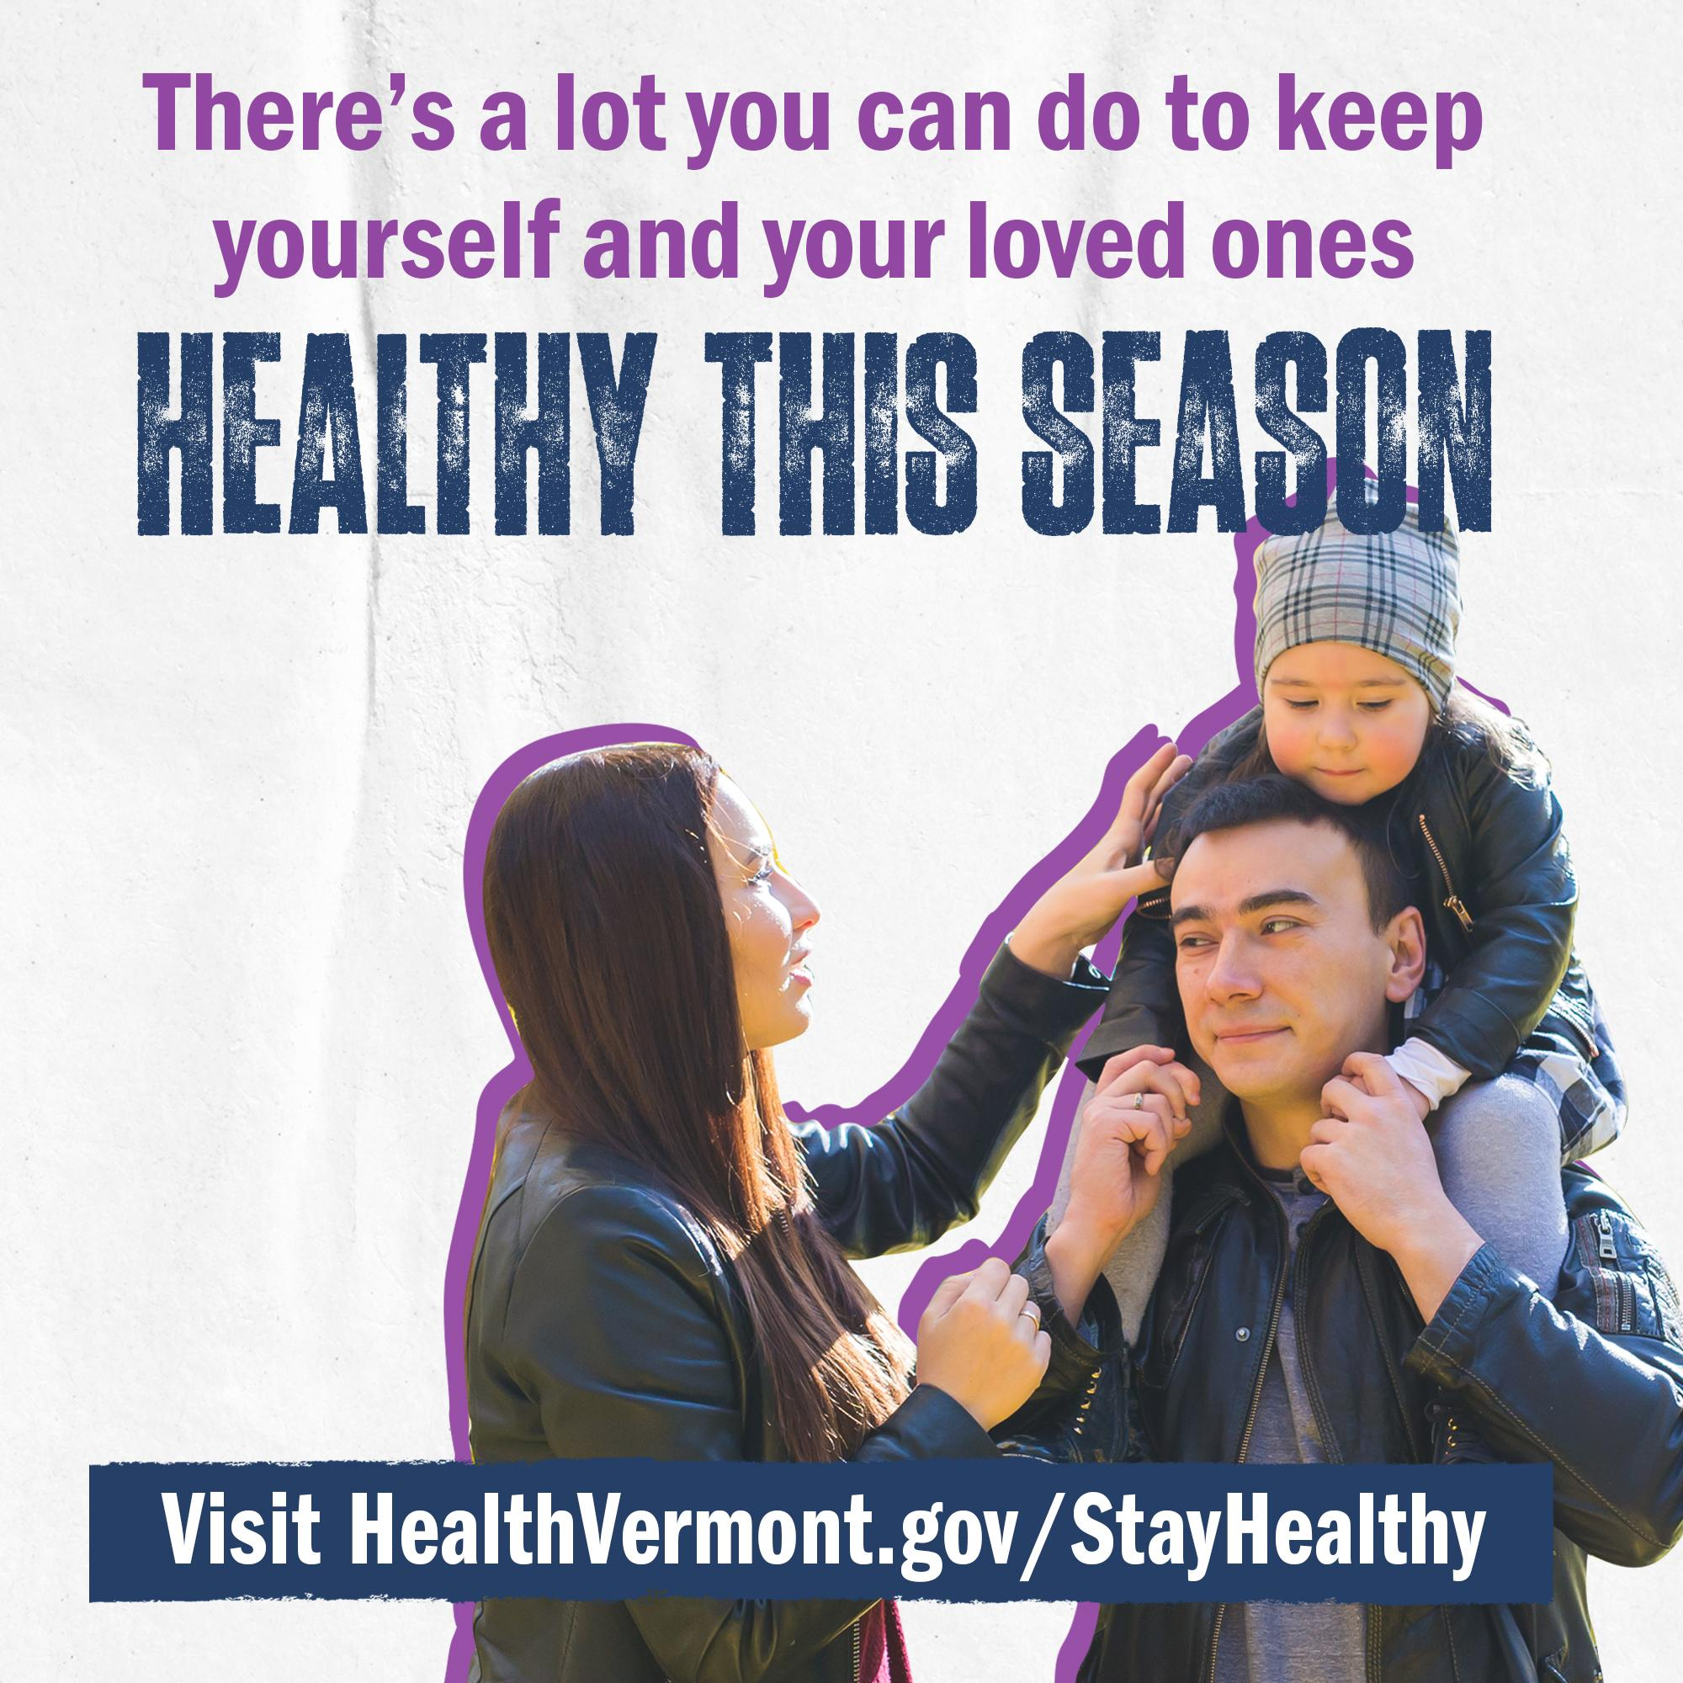  Link to Download
Post 10 - Prevention | There’s a lot you can do to keep yourself and your family healthy this winter—like these simple steps that prevent the spread of germs.  🧼Wash your hands often with soap and water.  🛏️Avoid contact with others if you or they are sick.  🤧Cover your coughs and sneezes with your elbow or a tissue.  😷Consider wearing a mask, especially if you or people you are with are at higher risk of serious illness.  💉Learn about this year’s vaccines and make a plan to get your shots.  Learn more about it at HealthVermont.gov/StayHealthy | 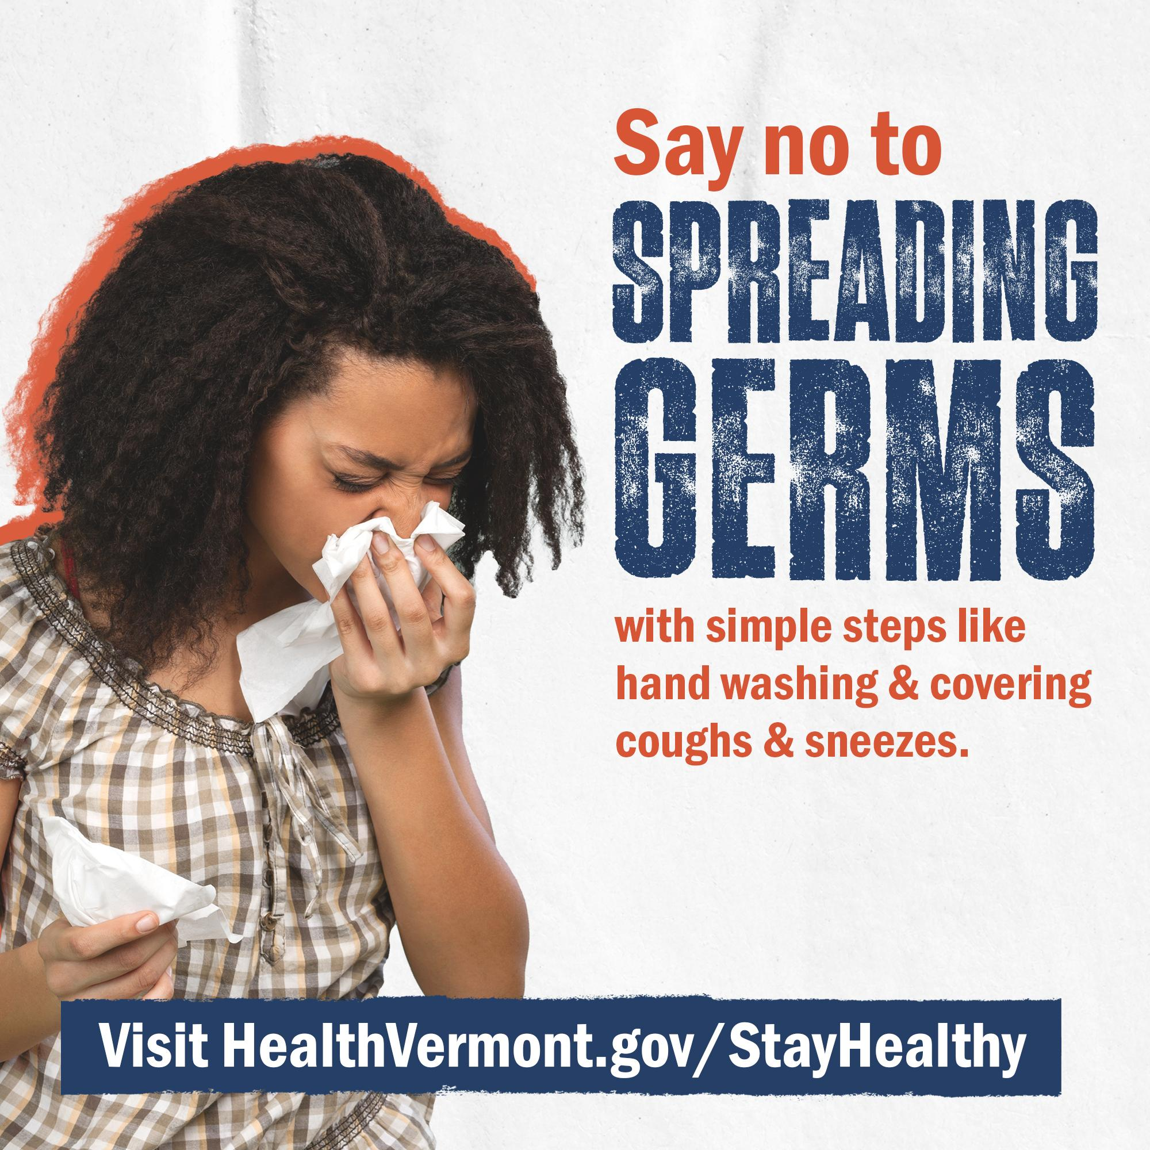  Link to Download
Post 11 - Prevention | Germs can be hard to avoid this time of year. But there’s a lot you can do to keep yourself and your loved ones healthy—including these everyday measures:  🧼Wash your hands often with soap and water.  🛏️Avoid contact with others if you or they are sick.  🤧Cover your coughs and sneezes with your elbow or a tissue.  😷Consider wearing a mask, especially if you or people you are with are at higher risk of serious illness.  💉Learn about this year’s vaccines and make a plan to get your shots.  For updates and info on this year’s vaccines, visit HealthVermont.gov/StayHealthy | 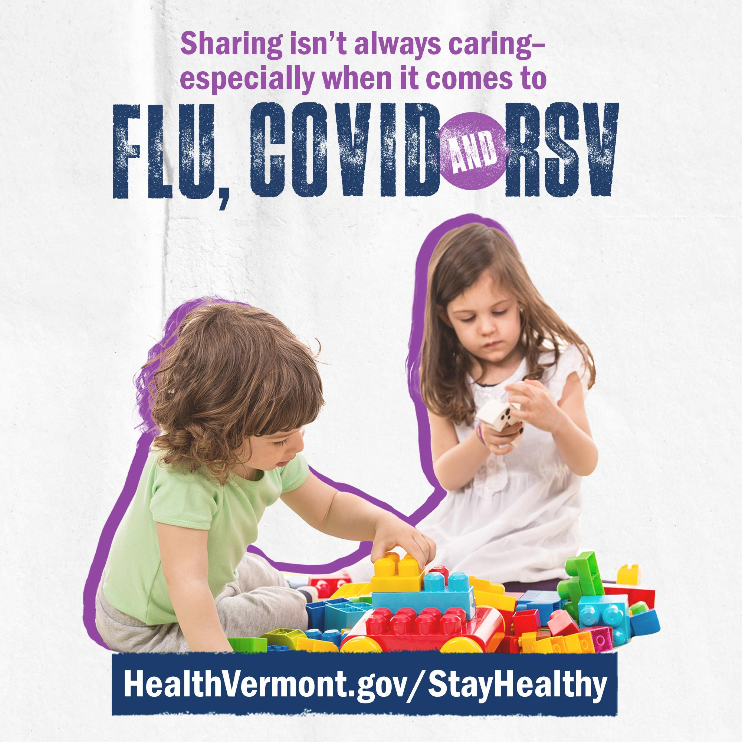  Link to Download
NEWSLETTER / BLOG / FRONT PORCH FORUM
Post 1 - Vaccines | It’s that time of year again! Getting vaccinated against flu, COVID, and RSV is one of the most important steps to stay healthy this season. These vaccines can help reduce the risk of severe illness and, if you do get sick, can make your symptoms milder and not as long lasting. Now is the time to get your flu and COVID shots, so you’re protected as we move into colder months and holidays.  Additionally, talk to your doctor about whether RSV immunizations are recommended for you or your family. RSV immunizations help protect babies and older adults from severe RSV. For more information, visit HealthVermont.gov/StayHealthy

