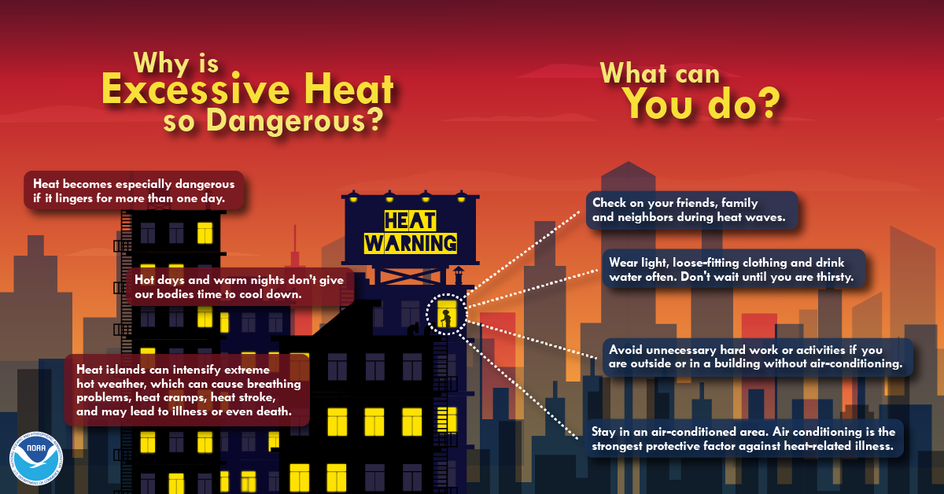

Hot Weather & Health:

Media Toolkit and Key Facts
Last Updated: July 2023

Hot Weather Media Toolkit
Last Updated: July 16, 2020

Hot Weather Media Toolkit
Last Updated: July 2022

Hot Weather Media Toolkit
Last Updated: July 16, 2020

Source: https://www.weather.gov/images/wrn/social_media/2017/excessive_heat_2018.png
Climate & Health Program

Climate & Health Program

Climate & Health Program

Climate & Health Program
healthvermont.gov/hot-weather

healthvermont.gov

healthvermont.gov

healthvermont.gov

This document provides outreach templates for use by Vermont Department of Health staff and its partners to provide consistent messaging to the media and public about heat-related illness risks and appropriate prevention and adaptation strategies. The first part of the document provides templates for Front Porch Forum and social media posts. The second part of the document provides key facts and information that can be used to develop additional messages.

Contents
Key messages
Front Porch Forum post
Social media posts
Hot weather forecast
Hot weather safety
Early season heat acclimation
Don’t be a stranger
Community cooling sites
Safety Tips for Communities
Heat Symptoms
Vehicle Safety
Teens and Young Adults
Outdoor workers
Keep Your Home Cool
Air Quality
Key facts about heat-related illnesses and risk factors in Vermont
Symptoms of heat-related illness and individual safety tips
Heat-related illness prevention guidance for specific audiences
Long-term adaptation guidance

Key messages
- Vermonters are at greater risk for serious heat-related illnesses, and even death, when temperatures reach the mid-80s and warmer.
- During the spring and early summer, hot weather can be especially harmful since our bodies are still adjusting to the warmer conditions.
- People at highest risk during hot weather include older adults and children, people active outdoors, people without air conditioning, and people with chronic medical conditions.
- Most heat-related illnesses can be prevented and treated through rest, shade and water.
- Please check on and aid friends, neighbors and loved ones that may need extra help staying safe during hot weather.
- Communities, employers, schools and other organizations should plan and prepare for preventing heat-related illnesses among the populations they serve.
- Hot weather is already harming health more frequently because of climate change, with even more frequent and intense periods of hot weather expected in the future.
- Visit the hot weather web page for more heat safety tips and a map of public places where you can cool off during hot weather.

Front Porch Forum post
Revise the yellow highlighted section as needed to reflect the current weather forecast.
Stay safe when it’s hot outside
The National Weather Service is forecasting high temperatures to reach the mid-90s on Sunday (July 19) for much of Vermont. High humidity could make it feel over 100°F. Nighttime lows may stay above 70°F in many locations, making it hard for people without air conditioning to keep cool.
Hot conditions make it easier for you become dehydrated or suffer from heat exhaustion or heat stroke. Many heat-related illnesses can be treated by resting in a cool location and drinking water. Severe heat-related illnesses can be life-threatening. Dial 9-1-1 or seek immediate medical help if you are concerned about your health or someone else's health when it’s hot.
Heat-related illnesses can affect certain groups of people more. These groups should take extra precautions: older adults and young children, people experiencing homelessness, people that work or exercise outdoors, people with chronic medical conditions, people taking certain prescription medications, and people using recreational drugs or alcohol. Risk is further elevated for people that live alone and do not have air conditioning.
Here’s how to stay safe when it’s hot outside:
- NEVER leave children, people with disabilities, older adults, or pets in parked vehicles.
- Wear lightweight, light-colored clothing to reflect heat and sunlight.
- Drink plenty of water, or non-alcoholic and non-caffeinated fluids.
- Take frequent rest breaks out of the sun.
- Limit outdoor activities during the hottest part of the day.
- Know where you can go for a break in air conditioning or cool water.
- Close window shades during the day, keep windows closed when it is hotter outside than inside, and avoid using appliances and lights that generate heat, if possible.
- Check on loved ones and neighbors, especially those living alone and without air conditioning.
Visit www.healthvermont.gov/hot-weather for a map of places where you can cool off and for more heat safety tips in 12 languages.

Social media posts
Please use #VTHeatSafety when messaging about hot weather. Revise the yellow highlighted sections as needed to reflect the current weather forecast. Find additional hot weather social media graphics:
- Heat infographics from the National Weather Service
- Social media graphics from the Centers of Disease Control and Prevention
- Extreme heat graphics from ready.gov
- Heat-related illness prevention from the Occupational Safety and Health Administration

Hot weather forecast
Facebook
High temperatures are forecast to be in the 90s with a heat index around 100°F for much of Vermont on Sunday. Keep your cool in hot weather!
- Drink more fluids than usual
- Take extra breaks from strenuous activities
- Seek shade and cool indoor locations
- Check in on loved ones and neighbors
Find more heat safety tips and a map of indoor cooling sites at www.healthvermont.gov/hot-weather #VTHeatSafety

Twitter
Temperatures are forecast to be in the 90s on Sunday. Drink fluids, take breaks, seek shade and cool indoor locations, and check in on loved ones and neighbors. Find more tips and indoor cooling sites at www.healthvermont.gov/hot-weather #VTHeatSafety

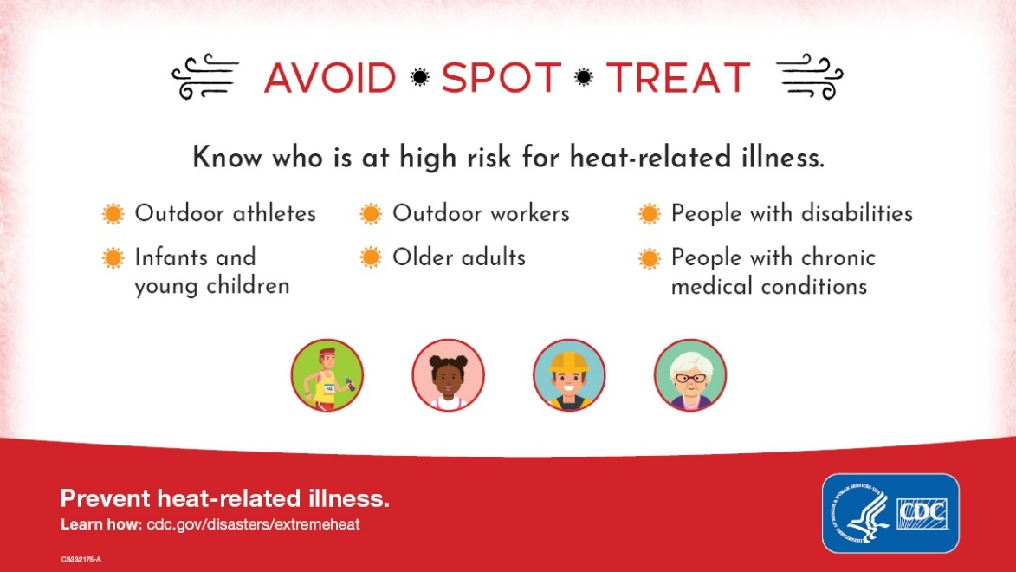
Download graphic

Hot weather safety
Facebook – general hot weather safety
Vermonters are at greater risk for serious heat-related illnesses, and even death, temperatures reach the mid-80s or hotter. Keep your cool in hot weather!
- Drink more fluids than usual
- Take extra breaks from strenuous activities
- Seek shade and cool indoor locations
- Check-in on loved ones and neighbors
Find more heat safety tips and a map of indoor cooling sites at www.healthvermont.gov/hot-weather #VTHeatSafety

Twitter
Keep your cool in hot weather! Drink more fluids than usual, take extra breaks from strenuous activities, seek shade and cool indoor locations, and check in on loved ones and neighbors. Find more tips at www.healthvermont.gov/hot-weather #VTHeatSafety

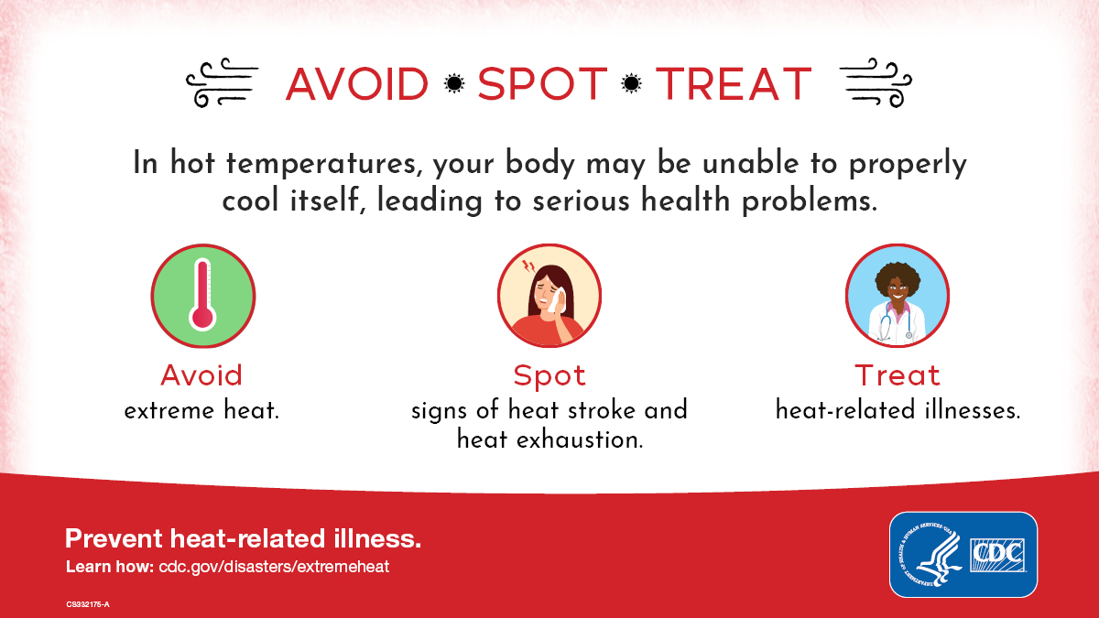
Download graphic

Facebook – heat wave
Heat can be dangerous. Heat can cause serious illness, even death. Stay cool, stay hydrated, and stay informed. Learn more about how to stay safe during the heat wave at www.healthvermont.gov/hot-weather #VTHeatSafety

Twitter
Heat can be dangerous. Heat can cause serious illness, even death. Stay cool, stay hydrated, and stay informed. Learn more about how to stay safe at www.healthvermont.gov/hot-weather #VTHeatSafety

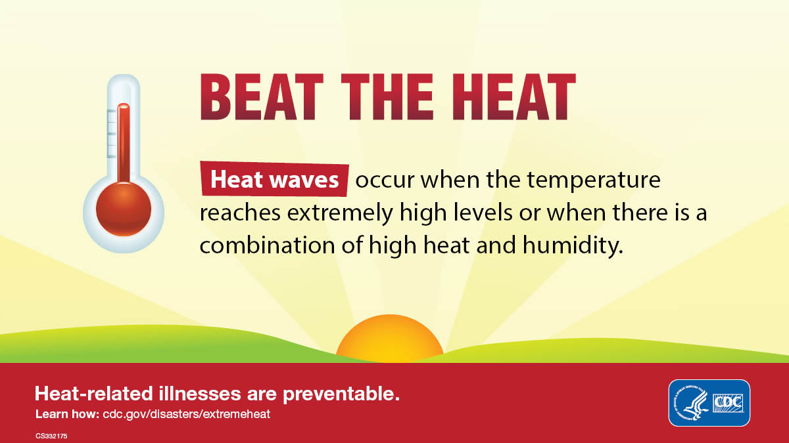
Download graphic

Early season heat acclimation
Facebook
In the spring, heat-related illnesses are common on days when the temperature reaches 80 or warmer. This is because it can take 7-14 days of gradually increasing your activity in the heat before your body fully adjusts to warmer weather. This time of year, it’s important to
- Ease into outdoor activities
- Take frequent rest breaks out of the heat
- Stay well hydrated
Find more heat safety tips at www.healthvermont.gov/hot-weather #VTHeatSafety

Twitter
It can take 7-14 days of gradually increasing your activity in the heat before your body fully adjusts to warmer weather. Ease into outdoor activities, take frequent rest breaks out of the heat, and stay well hydrated. Find more tips at www.healthvermont.gov/hot-weather #VTHeatSafety

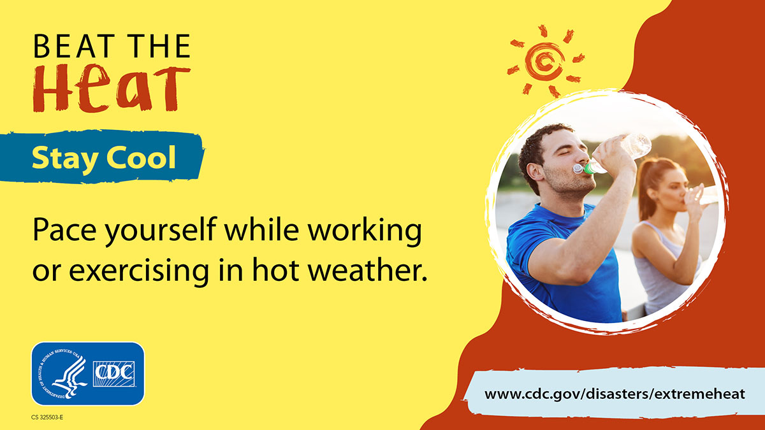
Download graphic

Don’t be a stranger
Facebook
Check on friends, loved ones, and neighbors to ensure they drink enough water and stay cool, especially if they live alone and don't have air conditioning. Remind them to take heat seriously!
More heat safety tips and a map of indoor cooling sites at www.healthvermont.gov/hot-weather #VTHeatSafety
Twitter
Most heat-related deaths in Vermont occur at home. Check on friends, loved ones, and neighbors to make sure they are drinking enough water and are staying cool. Find more tips at www.healthvermont.gov/hot-weather #VTHeatSafety

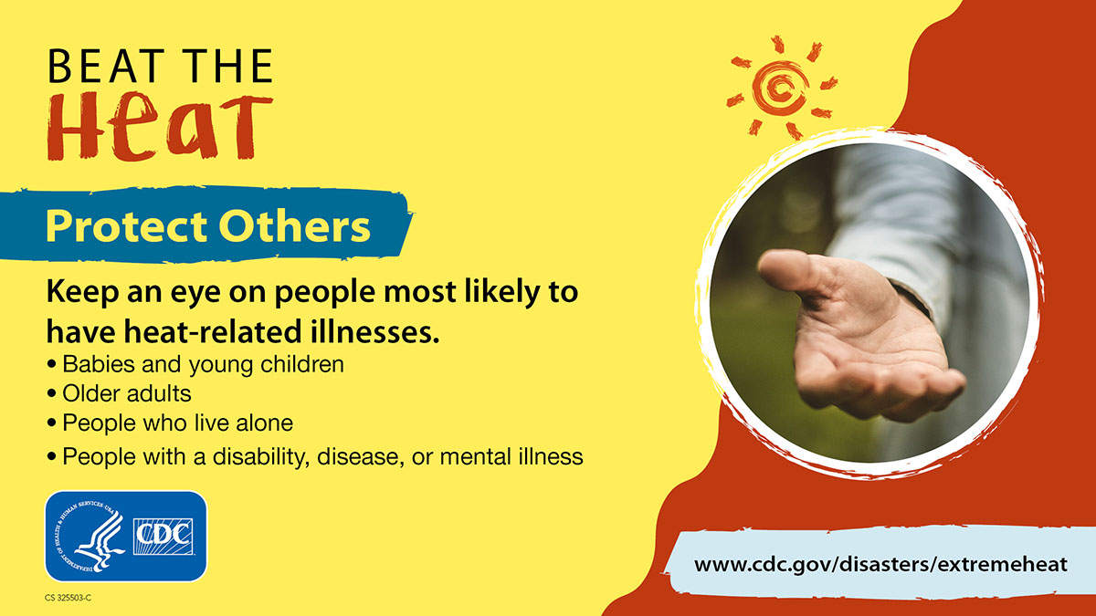
Download graphic

Community cooling sites
Facebook
When Vermont heats up, do you struggle to find places where you can go to cool off? We can help! Find a map of air-conditioned buildings, beaches, pools, and other cooling locations available to the public at www.healthvermont.gov/hot-weather #VTHeatSafety

Twitter
Looking for somewhere to go to get out of the heat? Find a map of air-conditioned buildings, beaches, pools, and other cooling locations available to the public at www.healthvermont.gov/hot-weather #VTHeatSafety

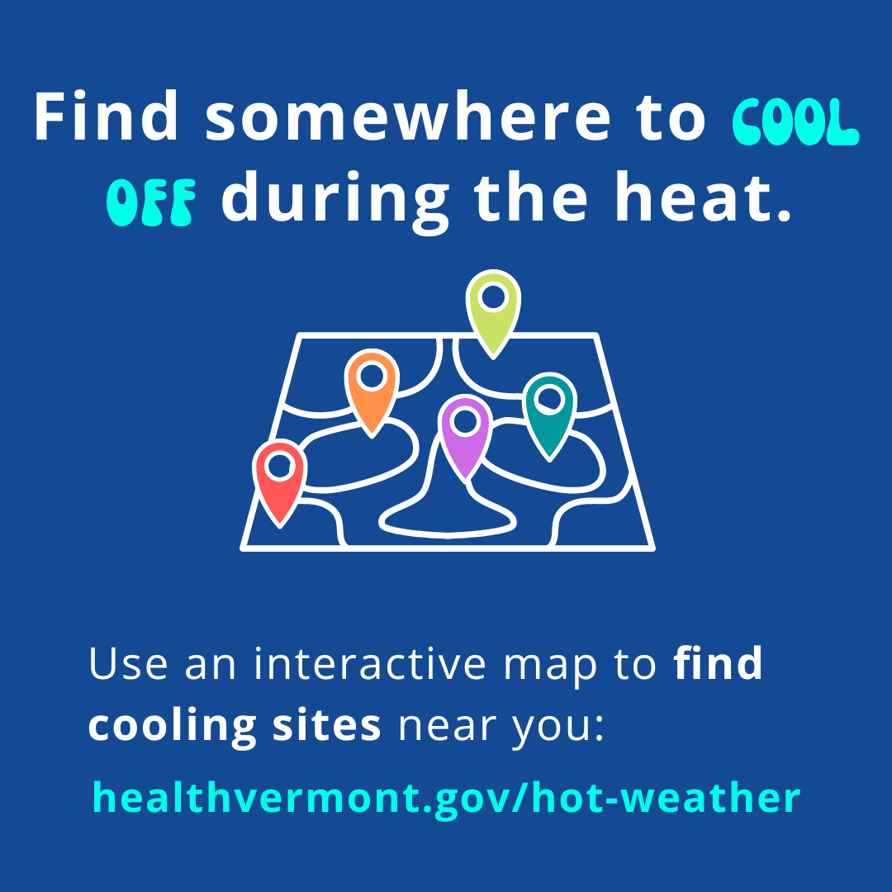
Download graphic

Safety tips for communities
Facebook
Is your community ready for hot weather? Try these suggestions:
- Identify an air-conditioned place that people can go to find relief.
- Offer fun ways to stay cool, such as free or extended access to beaches and pools, host events at air-conditioned places, or provide hoses, misters or cold beverages.
- Work with local partners to identify and offer help to residents that need extra help staying hydrated and cool.
Find more tips and hot weather emergency planning guidance at www.healthvermont.gov/hot-weather#prepare #VTHeatSafety

Twitter
Is your community ready for hot weather? Make sure people know where they can go to find relief and offer help to those who need help staying hydrated and cool. Find more tips and planning guidance at www.healthvermont.gov/hot-weather#prepare #VTHeatSafety

Heat symptoms
Facebook
During hot and humid weather, your body's ability to cool itself is challenged. When your body heats too rapidly to cool itself properly, or when too much fluid or salt is lost through dehydration or sweating, you may experience a heat-related illness. Learn the symptoms of heat-related illnesses, what first aid actions to take, and when to seek medical attention at www.healthvermont.gov/hot-weather #VTHeatSafety

Heat can affect anyone, but some people are at higher risk than others. Know the signs and symptoms of heat-related illness and call 9-1-1 if you are concerned about someone’s condition. Learn more at www.healthvermont.gov/hot-weather #VTHeatSafety

Twitter
During hot and humid weather, your body's ability to cool itself is challenged. Learn the symptoms of heat-related illnesses and what first aid actions to take at
www.healthvermont.gov/hot-weather #VTHeatSafety

Heat can affect anyone. Know the signs and symptoms of heat-related illnesses and call 9-1-1 if you are concerned about someone’s condition. Learn more at www.healthvermont.gov/hot-weather #VTHeatSafety

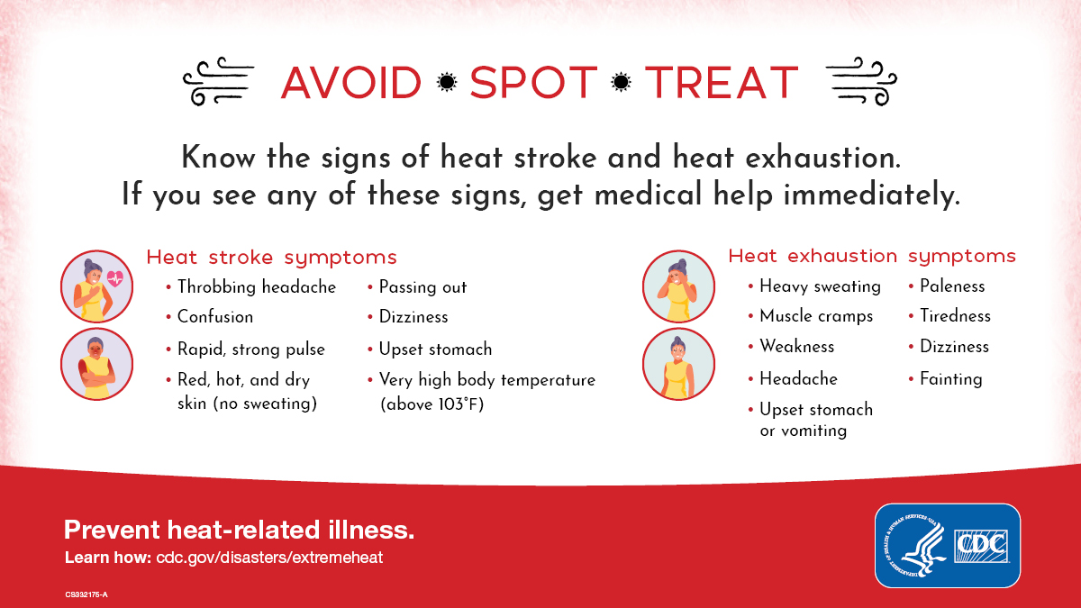
Download graphic for Facebook and Twitter

Vehicle safety
Facebook
NEVER leave children, people with disabilities, older adults, or pets in parked vehicles. Temperatures inside a parked vehicle can rapidly rise to a dangerous level. Leaving windows slightly open does not keep the vehicle cool enough. Effects can be more severe on children because their bodies can’t regulate temperature well. Look before you lock! Learn more at www.wheresbaby.org #VTHeatSafety

Twitter
NEVER leave children, people with disabilities, older adults, or pets in parked vehicles. Look before you lock! Learn more at www.wheresbaby.org #VTHeatSafety

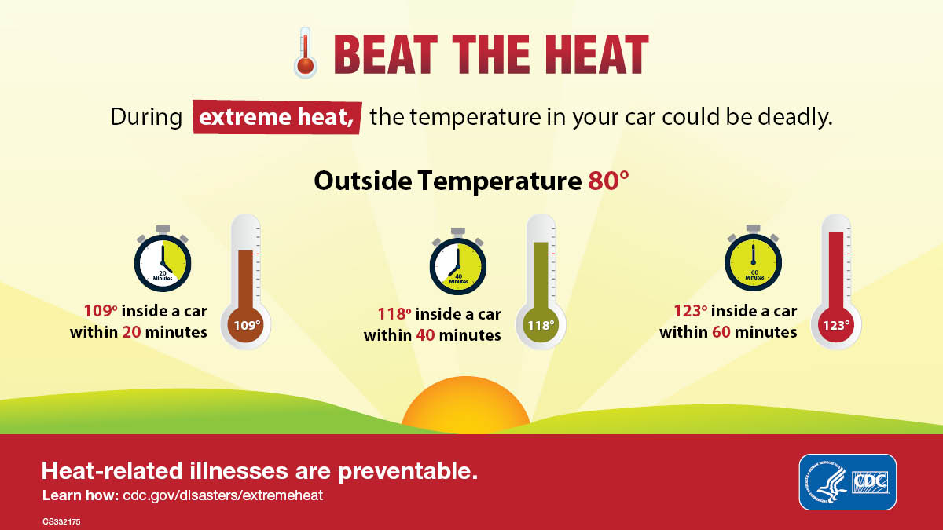Download graphic for Facebook and Twitter

Teens and Young Adults
Facebook
Did you know that teens and young adults are more likely that the average Vermonter to go to the emergency department for a heat-related illness? Protect yourself from the heat while working or playing outside.
- Drink plenty of water, or non-alcoholic and decaffeinated fluids.
- Limit outdoor activities during the hottest part of the day.
- Wear lightweight, light-colored clothing to reflect heat and sunlight.
- Seek relief in air-conditioned spaces or other cool and shady places.
Find more tips at www.healthvermont.gov/hot-weather #VTHeatSafety

Twitter
Protect yourself from the heat while working or playing outside. Drink more fluids than usual, take extra breaks in the shade, and wear lightweight, light-colored clothing. www.healthvermont.gov/hot-weather #VTHeatSafety

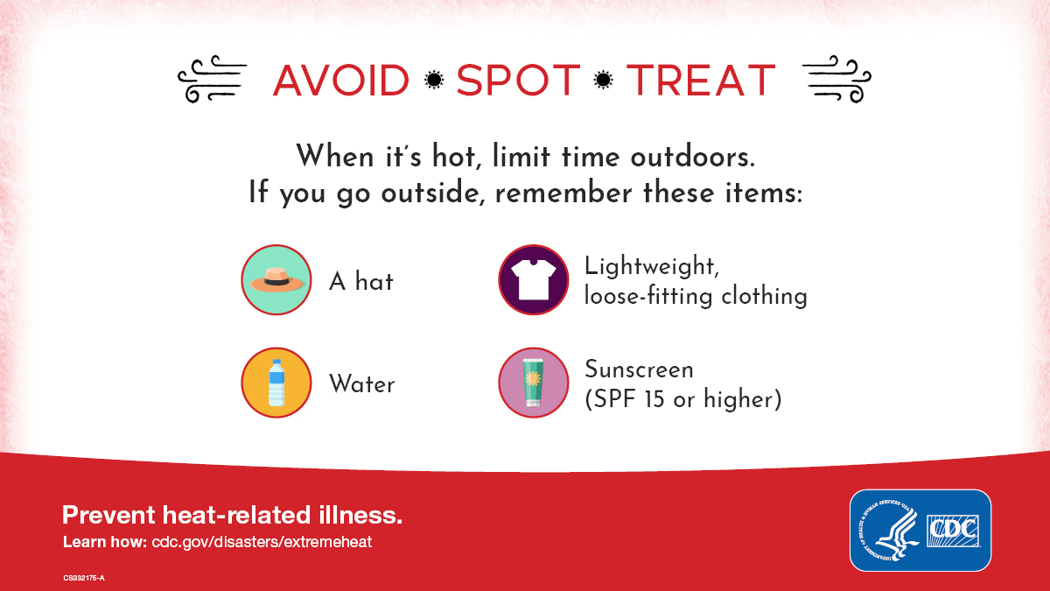
Download graphic

Outdoor workers
Facebook
Outdoor workers can be at higher risk for heat-related illnesses. During hot weather, outdoor workers need more water, rest breaks and shade than usual. Make sure your workplace has a policy to modify or cancel activities on hot days, and a plan for providing medical attention for a heat-related illness. Learn to recognize symptoms of heat-related illnesses and look out for each other! Learn more at labor.vermont.gov/vosha/heat #VTHeatSafety

It's going to be hot today! Be sure to get plenty of water, rest and shade if you're working outside. Check out tips for outdoor workers at labor.vermont.gov/vosha/heat #VTHeatSafety

Twitter
Is your workplace prepared for hot weather? Water, rest and shade are critical. Have a plan for reducing or canceling work on hot days, and for providing medical attention. Learn more at labor.vermont.gov/vosha/heat #VTHeatSafety
It's going to be hot today! Be sure to get plenty of water, rest and shade if you're working outside. Check out tips for outdoor workers at labor.vermont.gov/vosha/heat #VTHeatSafety

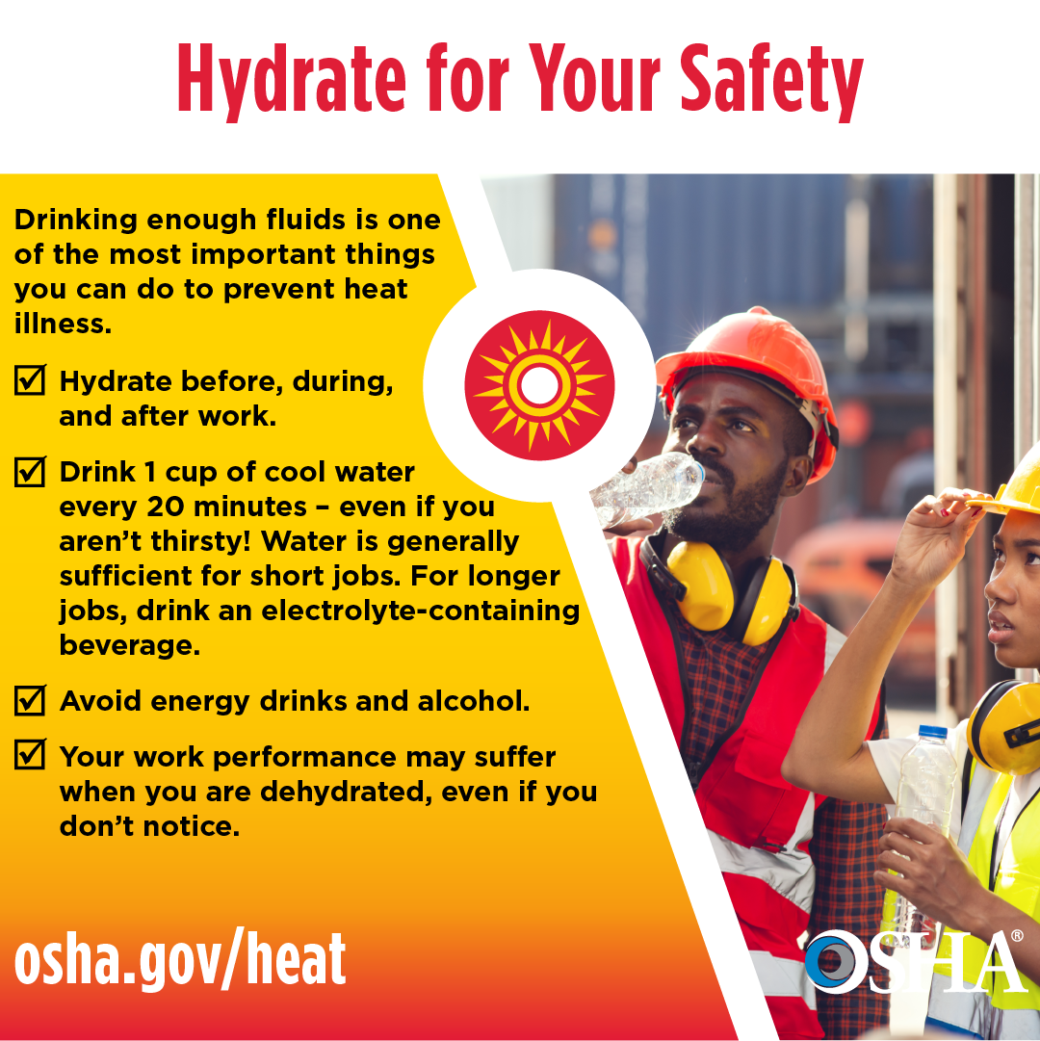
Download graphic

Keep your home cool
Facebook
If you don’t have air conditioning, try these tips to keep your home from heating up too much:
- Close window shades during the day.
- Keep windows closed when it is hotter outside than inside.
- Avoid using appliances and lights that generate heat, if possible.
- At night, open windows and use fans to blow in cooler outside air or vent out warmer inside air.
Find more tips at www.healthvermont.gov/hot-weather #VTHeatSafety

Twitter
Keep your home cooler by using window shades during the day, keep windows closed when it is hotter outside than inside, and avoid using appliances and lights that generate heat, if possible. Find more tips at www.healthvermont.gov/hot-weather #VTHeatSafety

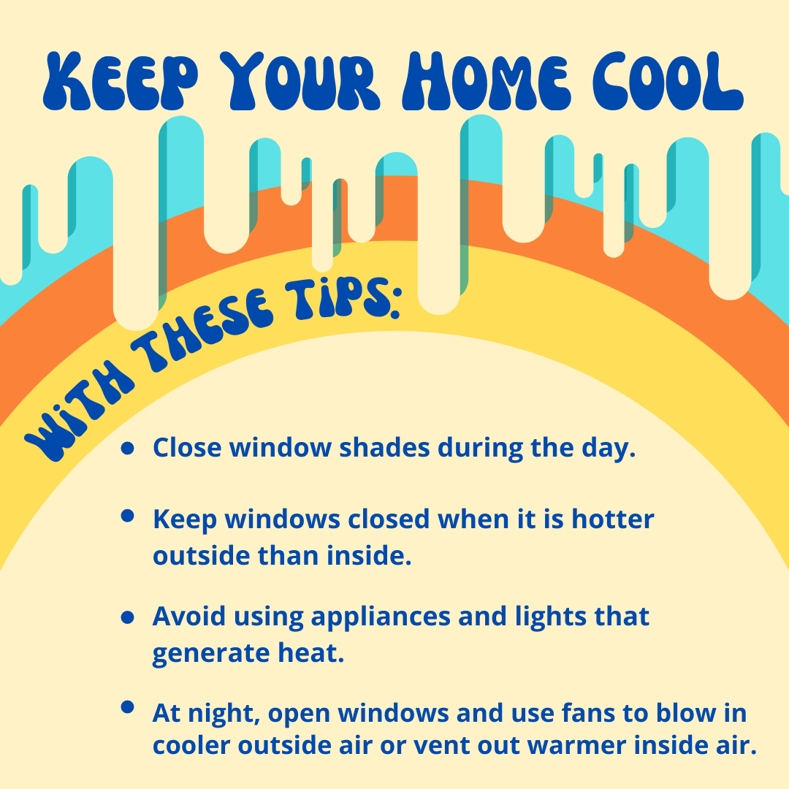
Download graphic

Air quality
Facebook
Hot weather can make air quality worse, possibly causing heart and respiratory problems for some people. Older adults, children, and people with a heart condition, asthma, or other respiratory condition tend to be at higher risk when air quality is poor. Stay safe by checking air quality alerts and forecasts. Sign up for alerts at www.airnow.gov #VTHeatSafety

Twitter
Hot weather can make air quality worse, possibly causing heart and respiratory problems for some people. Check air quality forecasts and sign up for alerts at www.airnow.gov #VTHeatSafety

Key facts about heat-related illnesses and risk factors in Vermont
Heat-related illnesses in Vermont
- Vermont averages over 100 heat-related emergency department (ED) visits and one heat-related death every year.
- During a 6-day heat wave in 2018, there were 90 heat-related ED visits and 4 deaths.
- These statistics only include victims where heat was specifically noted as a cause in the hospital or death record. It is widely known that heat-related ED visits and deaths are undercounted, possibly by as much as a factor of 10, as heat is known to worsen a variety of chronic medical conditions, including diabetes, kidney, cardiovascular, respiratory, and cerebrovascular diseases.
- Heat-related ED visits in Vermont are most common among older adults, teenagers, and young adults.
- Most heat-related deaths occur in older adults. Underlying health conditions, a lack of air conditioning, and living alone are often contributing causes.
- Vermont residents experience heat-related illnesses at lower temperatures than in many other parts of the country. Because we experience hot weather so infrequently:
  - It’s hard for our bodies to acclimate to hotter conditions.
  - It can be hard to adapt our behaviors to stay safe during hot weather.
  - Many homes are not adequately weatherized and do not have air conditioning.
  - We have not developed plans and policies needed to be prepared for hot weather.
  - We have a large population of older adults, who are at more risk for heat-related illnesses.
How do weather, season, and geography affect the risk for heat-related illness?
- Vermonters are at greater risk for serious heat-related illnesses, and even death, when temperatures reach the mid-80s and warmer.
- Heat-related ED visits increase as the heat index increases. Compared to days when the heat index is in the 80s at the Burlington International Airport weather station, heat-related ED visits are twice as common on days when the heat index is in the low 90s and four times as common on days when the heat index is in the upper 90s.
- The risk for heat-related illnesses depends on the climate a person is used to. For example, 85°F in relatively cool places like Newport or Montpelier is just as risky to the local population as is 90°F in comparatively warm places like Burlington and Springfield.
- Other factors that increase the risk for heat-related ED visits include:
  - Being early in the warm season
  - When high temperatures over the past week have been relatively cool
  - When it was also hot yesterday
  - When it was warm overnight
- Heat-related illnesses and deaths occur more frequently in urban areas than in rural areas. Urban areas tend to feel hotter during the day and cool down less overnight. This is caused by urban areas having more pavement and rooftops with less tree cover than rural areas.
Who is at highest risk?
- People with more exposure to hot conditions, including:
  - Outdoor workers and hobbyists
  - People experiencing homelessness
  - Urban residents
  - People in buildings without air conditioning
- People more sensitive to heat exposure, including:
  - Anyone not acclimated to warmer weather
  - Older adults and young children
  - People who are overweight or have chronic medical conditions
  - People who use recreational drugs, alcohol or some prescription meds
    - including those that narrow your blood vessels (vasoconstrictors), regulate your blood pressure by blocking adrenaline (beta blockers), rid your body of sodium and water (diuretics), reduce psychiatric symptoms (antidepressants or antipsychotics), or stimulants for attention-deficit/hyperactivity disorder (ADHD)
- People with limited adaptation resources, including:
  - Living alone
  - No personal transportation options
  - No air conditioning or can’t afford to run it
How is climate change affecting heat-related health risks?
- Average temperatures in Vermont have already risen by 3°F since 1900.
- At the Burlington International Airport, hot days (exceeding 90°F) and warm nights (above 70°F) occurred more than twice as often since 2010, as compared to the previous 60 years.
- The period from 2010-2020 was the warmest on record for Vermont.
- Heat-related ED visits increased by more than two per year from 2009-2019.
- Average temperatures are projected to increase by an additional 3 to 12°F by 2100.
- From 1981-2010, there were fewer than 7 days per year on average when temperatures reached 90°F at the Burlington Airport. Since 2010, that number has increased to nearly 11 days per year. This number is expected to further increase to 15-20 days per year by mid-century and 20-34 by the end of the century.
- As temperatures continue to warm, heat-related health risks are expected to increase.

Symptoms of heat-related illness and individual safety tips
Symptoms of heat-related illnesses and basic first aid
- Common symptoms include muscle cramps, weakness, heavy sweating, nausea, vomiting and dizziness.
- Symptoms can usually be treated by resting in a cool, shady place and by drinking cool beverages.
- If symptoms do not improve or if confusion or fainting occurs, seek immediate medical attention, as heat stroke can result in death.
- Find more info about heat-related illness symptoms and first aid.
Most heat-related illnesses can be prevented
- Reduce outdoor activity during the hottest part of the day.
- Stay hydrated, and avoid alcohol and caffeine if possible.
- Wear light-colored and light-fitting clothes.
- Seek relief in air-conditioned spaces or other cool and shady places.
- Use the Vermont community cooling site map to find public places to cool off on hot days.
- Keep your house cool by using shades, windows, fans and avoiding use of oven/stove.
- Never leave children, adults with disabilities, or pets in a parked vehicle.
- Learn the signs and symptoms of heat-related illnesses and basic first aid responses.
- Check in on friends, neighbors and loved ones, especially those living alone.
- Stay informed by tuning in to weather, news, and emergency messaging.
- Find more heat safety tips in 12 languages.
Seasonal heat acclimation
- Hot weather early in the year can be particularly dangerous.
- It typically takes 7-14 days of activity in hot weather for a person to adapt to warmer conditions.
- As the weather warms, it is important to ease in and gradually increase outdoor activity.
- When hot days are infrequent, very little acclimatization will occur; acclimatization diminishes after a few weeks without hot weather exposure.
Stay informed of heat risks and safety guidance
- Subscribe to VT-Alert to receive weather safety alert.
- Follow local weather forecasts and see statewide heat data from the National Weather Service.
- See heat risk maps for the next week from the National Weather Service.
- Follow @NWSBurlington, @healthvermont, @vemvt and #VTHeatSafety on social media.

Heat-related illness prevention guidance for specific audiences
Prevention guidance for health care and emergency medical providers
- Be prepared to treat a higher number of heat-related conditions than usual.
- Make sure that air conditioning or other cooling systems are in place and functioning.
- If cooling systems are not available, or malfunction, have a plan in place for providing emergency cooling or relocating people to a cooler location.
- Have a plan for checking in on people at higher risk to make sure they stay hydrated and can stay cool in their location.
- Consider how medications could increase risk for dehydration and heat-related illnesses.
- Consider how hot conditions may affect a patient or client before sending them home.
- If staffing an outdoor event, make sure that event organizers are well prepared with water, cooling strategies, and plans to modify or cancel the event if needed.
- Remember that hot weather can affect anyone. Be sure your organization has a heat management plan for employees and volunteers. Be aware of your own symptoms and look out for your colleagues.
Prevention guidance for human service providers
- Use front porch forum or social media to raise awareness – examples are provided in our Hot Weather Media Toolkit.
- Be familiar with symptoms of heat-related illnesses and first aid responses.
- Have a plan for checking in on people at higher risk to make sure they stay hydrated and can stay cool in their location.
- Make sure that air conditioning or other cooling systems are in place and functioning.
- If cooling systems are not available, or malfunction, have a plan in place for providing emergency cooling or relocating people to a cooler location.
- Provide guidance on hydration, appropriate clothing, diet, and other ways to stay cool.
- Consider how medications could increase risk for dehydration and heat-related illnesses.
- Consider modifying or cancelling any strenuous activities during hot weather.
- Remember that hot weather can affect anyone. Be sure your organization has a heat management plan for employees and volunteers. Be aware of your own symptoms and look out for your colleagues.
Prevention guidance for schools and child care providers
- Make sure that staff are familiar with symptoms of heat-related illnesses and first aid responses. Have an emergency plan in place for providing medical attention in the event of a serious heat-related illness.
- Have a plan for monitoring children at higher risk to make sure they stay cool and hydrated.
- Provide guidance on hydration, appropriate clothing, diet and other ways to stay cool. Provide or make sure students have easy access to water, ice and cool spaces.
- Limit outdoor and physical activity. Provide frequent rest and hydration breaks. Follow the Vermont Principals’ Association Hot Weather Policy for athletic activities.
- Make sure that air conditioning or other cooling systems are in place and functioning
- Use window shades to keep out sun and absorb heat. If windows can’t be covered, rearrange the room to keep everyone out of direct sun.
- Turn off lights, electronic equipment and other heat-generating equipment if practical.
- In rooms without air conditioning, use fans to blow in cool air and vent our warm air when the temperature outside is cooler or similar to inside. Fans are ineffective when temperatures reach the mid-to-upper 90s. If possible, keep windows open overnight to help cool the building.
- If a room becomes too hot and uncomfortable, move to a shaded outdoor location or to a cooler indoor location, if possible. Basements and lower floors will stay cooler than upper floors. If cooled space is limited, rotate students through cooler spaces throughout the day.
- Consider closing the facility or ending early if indoor temperatures get uncomfortably hot.
Prevention guidance for employers
- Provide all workers with water, rest breaks and shade.
- Establish a policy for modifying or cancelling strenuous activities on hot days.
- Make sure that you and your workers can recognize symptoms of heat-related illnesses and are looking out for each other.
- Have an emergency plan in place for providing medical attention in the event of a serious heat-related illness.
- Find additional heat safety guidance from the Vermont Department of Labor.
Prevention guidance for communities
- Use Front Porch Forum or social media to raise awareness – examples are provided in our Hot Weather Media Toolkit.
- Be familiar with symptoms of heat-related illnesses and first aid responses.
- Offer safe and fun ways to stay cool, such as free or extended access to beaches and pools, providing hoses or misters, and offering free cold beverages.
- Consider opening a cooling center, which could be any air-conditioned, publicly accessible location (for example, a library or community center)
- Mobilize local care networks to check in on people at high risk for heat-related illnesses.
- For outdoor work, recreational activities, or other local events, ensure that organizes are prepared with water, cooling strategies, and event modification or cancellation plans.
- Hot weather can affect anyone – be aware of your own symptoms and look out for others
- Find detailed hot weather planning guidance and a planning template.
Prevention guidance for event managers
- Provide plenty of water, shade and indoor cooling options.
- Establish a policy for modifying or cancelling strenuous activities on hot days.
- Make sure that event staff and volunteers can recognize symptoms of heat-related illnesses.
- Have a plan in place for providing medical attention in the event of a serious heat-related illness.

Long-term adaptation guidance
Long-term adaptation guidance for individuals
- Modify buildings and ventilation systems to increase cool air flow while venting out hot air.
- Seal air leaks and properly insulate to help keep buildings cool in summer and retain heat in winter.
- Plant trees, shrubs, and vines around buildings to maximize summer shade and cooling breezes.
- Replace incandescent light bulbs with LED bulbs that stay much cooler and save energy.
- Put in air conditioners, heat pumps or similar cooling devices.
Long-term adaptation guidance for communities
- Prepare a hot weather emergency plan that:
  - identifies roles and responsibilities
  - identifies locations that could be used as cooling centers
  - identifies volunteers and emergency personnel that could check in on high-risk populations
  - establishes practices and policies for limiting or canceling athletic activities, outdoor work, public events, or other outdoor activities during hot weather
- Pre-identify individuals that may be particularly vulnerable to hot weather and establish plans for protecting their health.
- Modify buildings and cooling systems to increase ventilation and reduce building temperatures.
- Plant trees and shrubs and reduce paved surfaces to keep urbanized areas cooler,
- Find detailed hot weather planning guidance and a planning template.

